New Hampshire
MMIS Procurement System
Documentation

Chapter 10: Service Authorization
Part D

Version 15.1
Deliverable Tracking Number NH-186-SYSDOC

July 05, 2026

© 2026 Conduent, Inc. All rights reserved. Conduent® and Conduent Agile Star® are trademarks of Conduent, Inc. and/or its subsidiaries in the United States and/or other countries.
Document Version: July 05, 2026

Service Authorization Part D Table of Contents
10. Service Authorization 10-1
10.2 Service Authorization: Processes (continued) 10-1
10.2.4 Process: SA Letters, Reports & Outputs 10-1
10.2.4.1 Workflow Diagram NH-WF-OPR-10-003 - SA Letters, Reports and Outputs 10-4
10.2.4.2 Use Case UC-OPR-SRA-020.2 – SA Letter Administration 10-5
10.2.4.2.1 Browser Page Definition UIS-FIN-SRA-010.3- SA Letter Assignment 10-10
10.2.4.3 Use Case UC-OPR-SRA-020.1 - Service Auth Letters 10-23
10.2.4.3.1 Report Definition 10-28
10.2.4.3.2 Letter Definition OPR-SA-L001 Service Authorization Notification 10-28
10.2.4.3.3 Letter Definition OPR-SA-L002 - Request for Additional Information 10-42
10.2.4.3.4 Letter Definition OPR-SA-L003 - Notice of a Change in Authorized Services 10-55
10.2.4.3.5 Letter Definition OPR-SA-L004 - Service Authorization Manual Letter 10-68
10.2.4.3.6 Letter Definition OPR-SA-L005 - Service Authorization Co-Pay Letter 10-75
10.2.4.3.7 Letter Definition OPR-SA-L006 - Service Authorization 810 10-83

Service Authorization

Service Authorization: Processes (continued)

Process: SA Letters, Reports & Outputs
Process Overview

Service Authorization Letters
The NH MMIS has many options to tailor Service Authorization (SA) letters based on the needs of specific program areas. Letter options include the ability to specify the rules/conditions for sending a letter, the letter template used to produce the letter, the people who will receive the letter, the sender’s contact information, and disclosures and enclosures to include with the letter. Letter requirements will be entered and maintained in SA Letter Assignment records using the SA Letter Administration browser page under the Rules Management menu.
Letter generation is a two-step process. First, letter generation trigger records are created and stored in the Letter Trigger Table following certain events. Trigger events might include: adding a new SA record, updating an SA record, receiving an SA or SA update from a third party system, changing the approved units/dollars on a previously approved SA, or changing the header status of an SA record.
In the second step, which occurs on a scheduled basis, (see UC-OPR-SRA-020.1 - Service Auth Letters), the letter generation triggers are used to generate the actual SA letters based on the active Letter Assignment Records (see UC-OPR-SRA-020.2 – SA Letter Administration and UIS-FIN-SRA-010.3 SA Letter Assignment). The SA Letter Assignment record is used to define the criteria for determining if a letter is produced, the template used to produce the letter, supplemental enclosures, and to whom letters will be sent. Typically, letters are formatted and printed at a print vendor, but providers (e.g. Area Agency) letters can optionally be formatted and delivered to their provider Inbox.
In addition to systematically generated letters, manual letters can be created by Users in the Letters and Responses section of the Service Authorization browser page.
Six custom letter templates were designed for the NH Medicaid program:
OPR-SA-L001 - Service Authorization Notification
OPR-SA-L002 - Request for Additional Information
OPR-SA-L003 - Notice of a Change in Authorized Services
OPR-SA-L004 - Service Authorization Manual Letter
OPR-SA-L005 - Service Authorization Co-Pay Letter
OPR-SA-L006 - Service Authorization 810 Letter

Letter triggers will be used to create letters during a nightly batch process. See Use Case UC-GLB-LTR-02.2 – Batch Letter Generation, Chapter 27, Part C. Daily and weekly reports are produced to allow monitoring of the letter generation process. Detailed descriptions of these reports can be found in Technical Requirements, Chapter 27, Part C. The reports are as follows:
GEN-LTR-001 – Daily Opened Letter Request Report. List all request for the day.
GEN-LTR-002 – Daily Processed Letter Request Report. List all letters produced in the daily batch cycle.
GEN-LTR-003 – Daily Overdue Letter Request Report. List all batch requests that have not been processed.
GEN-LTR-004 – Weekly Opened Letter Request Report. List all requests that was open for the week.
GEN-LTR-005 – Weekly Processed Letter Request Report. List all request processed for the week.
Images of all letters will be stored in EDMS. This process is described in UC–EDMS-API-017 - File Upload located in Technical Requirements, Chapter 27, Part D. The letter images will be linked to the related Service Authorization ID number.

Service Authorization Reports
Eighteen custom reports were developed for the NH Medicaid program. Operational reports were developed for government reporting purposes, tracking service metrics, measuring user workload and productivity, quality assurance and decision support. Reports will be used to track eligibility gaps, unspent SA dollars, approved but unused SA’s, cost avoidance statistics, provider utilization, member utilization, user productivity and processing lag time.
Operational reports can be set up to run on a scheduled basis and/or they can be run when requested by a user (on request). Reports designed to be run on request typically allow the report requester to specify the report parameters such as a date range, Auth Type, SA Category Code, specific provider or specific member. Once a report is produced, the report can be exported to MS Excel or MS Access and the data can be used to create graphs and charts.

The NH SA Operational Reports are as follows:
OPR-SRA-101 – Service Authorizations Not Used Within Four Months of the Line Item Begin Date
OPR-SRA-104 – Service Authorization Service Code Utilization by Provider
OPR-SRA-105 – Service Authorization Service Code Utilization by Member
OPR-SRA-107 - Service Authorization Pended over 10 Days
OPR-SRA-108 – Service Authorization Processing Benchmark
OPR-SRA-109 - Service Authorization Requesting Independent Clinical Review or Appeal
OPR-SRA-110 - Service Authorization Lagging
OPR-SRA-111 – Service Authorization Unused Dollars
OPR-SRA-114 – Frequency of Requested and Authorized Service Codes
OPR-SRA-115 – Service Authorization Utilization by Member
OPR-SRA-116 - DCYF/DJJS Service Authorization and Eligibility Discrepancies
OPR-SRA-123 - Service Authorization Utilization by Provider
OPR-SRA-124 - Service Authorization Cost Avoidance
OPR-SRA-125 - Service Authorization Inventory Summary
OPR-SRA-126 - Service Authorization Internal User Productivity
OPR-SRA-127 - Service Authorization Member Eligibility Gap
OPR-SRA-128 - Service Authorization Suspect Duplicates
OPR-SRA-129 - Service Authorization Weekly Report by Status
OPR-SRA-131- SA Over-Utilization Report

Service Authorization Request x12 278 Outbound
ASC X12N 278 Transactions are Service Authorization requests received from providers with EDI transaction capabilities. SA request transactions are received from EDI and processed as a batch file. The system performs data validation and error detection on the SA requests. If an SA request is successfully received via an X12N 278 transaction, an X12N 278 acknowledgement transaction is sent to the original submitter (of the SA request) to confirm receipt of the SA request. The SA is then passed through the SA Adjudication process and processed in the same manner as an SA received via web, mail, or facsimile. All subsequent notifications/responses to the member or provider(s) will be sent in the form of letters. In addition, providers who submit SA requests via the X12N 278 transaction will receive an x12N 278 Response when the SA is finalized and each time it is adjusted.
The X12N 278 Process is as follows:
- The X12N 278 Transaction is received and acknowledged in the process described in UC-PGM-EDI-001 in Chapter 8, and Part A).
- The EDI sends either a positive or negative 997 to the submitter (see UC-PGM-EDI-002, Process Outbound 997 Handling – Outbound X12N 997 Transactions in EDI, Chapter 8, and Part A). All subsequent notifications/responses to the member or provider(s) will be sent in the form of letters. In addition, providers who submit SA requests via the X12N 278 transaction will receive an x12N 278 Response when the SA is finalized and each time it is adjusted.
- The MMIS then pulls the XML file from EDI - see UC-OPR-SRA-005.1 – Service Auth Request x12 278 Inbound
- The MMIS then reformats the SA data into the MMIS format.
- The new or revised SA is sent to the SA Adjudication process UC-OPR-SRA-023 where it is processed by the MMIS, including: performing calculations, populating fields, editing and posting exceptions, assigning locations and users, rejecting the add/update (if applicable), assigning a location and SA-ID number and storing the file to the MMIS database.
- After the SA is adjudicated, letters are produced and mailed based on the active records defined in the SA Letter Assignment records and based on related business rules.
- Providers who submit SA requests via the X12N 278 transaction will receive an x12N 278 Response when the SA is finalized and each time it is adjusted.

Outbound SA Interfaces
The MMIS Service Authorization Subsystem includes a number of electronic inbound and outbound interfaces to other systems used to enter and manage Service Authorization records. These interfaces eliminate the need for double data entry and ensure that all of NH Medicaid’s (non-pharmacy) SA records are stored in one central location. The MMIS will receive and validate SA records/updates, reformat and map the data into the NH MMIS SA database. Once successfully stored in the MMIS, these SA records can be used to process claims, generate letters and produce operational reports. The following list of outbound interfaces will be used to send claims and utilization information back to the original source systems and to report utilization information to the LEADS program. Additional information on interfaces can be found in Chapter 34 as follows:
Bridges SA Output Interface (Chapter 34, Part M)
OPTIONS SA Output Interface (Chapter 34, Part C)
LEADS Output Interface (Chapter 34, Part J)

Workflow Diagram NH-WF-OPR-10-003 - SA Letters, Reports and Outputs
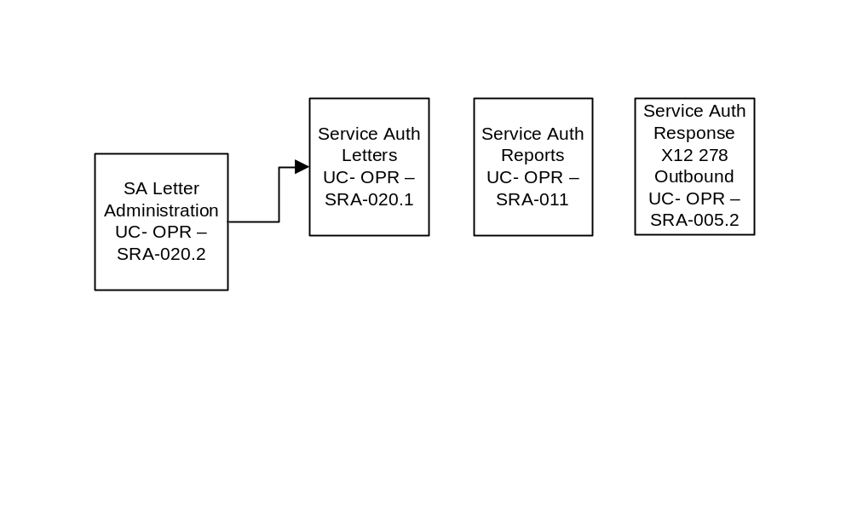

Use Case UC-OPR-SRA-020.2 – SA Letter Administration

Name
SA Letter Administration

ID
UC-OPR-SRA-020.2

Description
The Service Authorization System includes functionality to produce SA letters to providers, members and additional parties. The SA Letter Assignment record (see UIS-FIN-SRA-010.3 – Service Authorization Letter Assignment), is used to define the criteria for determining if a letter is produced, the template used to produce the letter, supplemental enclosures, and the letter recipients. This Use Case describes the process for creating SA Letter Assignment records.

Actors
State User, FAS User

Preconditions
Actor is authorized to Add and Update SA Letter Assignment records.

Trigger
Actor elects to add or update a SA Letter Assignment record.

Post Conditions
A SA Letter Assignment is created or updated and saved to the database.
Basic Flow – Enter a new SA Letter Assignment Record
Step # | Actor Action | System Response | Related Artifacts (List IDs) | Step Remarks
1 | Actor navigates to the Service Authorization Letter Assignment browser page. | System displays the SA Letter Assignment browser page.  Alternate Flows #2, #3, #4 and Exception Flow #2, apply to any step of the Basic Flow. | UIS-FIN-SRA-010.3
2 | Actor elects to add a new SA Letter Assignment record. | System opens the SA Letter Assignment browser page in Add mode.  Refer to Alternate Flow #1 | UIS-FIN-SRA-010.3
3 | Actor enters SA Letter Assignment details and Actor initiates the “Save” function. | System validates data on the SA Letter Assignment record and System saves the SA Letter Assignment record to the database.  See Exception Flow #1 | UIS-FIN-SRA-010.3  Business Rules:  SRA2001.0116.01–  9-1060-0032  SRA2001.0117.01-  9-1060-0033  SRA2001.0118.01  9-1060-0034  SRA2001.0127.01-  9-1060-0117
4 |  | System confirms that the record was successfully saved to the database.  System Use Case Ends. | UIS-FIN-SRA-010.3

Alternate Flow 1- Update an existing SA Letter Assignment Record
Step # | Basic Flow Step # | Actor Action | System Response | Related Artifacts (list IDs) | Step Remarks
1 | 2 | Actor elects to update an existing SA Letter Assignment record. |  | UIS-FIN-SRA-010.3
2 | 2 | Actor selects an existing SA Letter Assignment record by clicking on the grid row. | System displays the SA Letter Assignment record in edit mode. | UIS-FIN-SRA-010.3
3 | 2 | Actor updates SA Letter Assignment details initiates the “Save” function. | System validates data on the SA Letter Assignment record and System saves the SA Letter Assignment record to the database.  See Exception Flow #1 | UIS-FIN-SRA-010.3  Business Rules:  SRA2001.0116.01–  9-1060-0032  SRA2001.0118.01-  9-1060-0034  SRA2001.0127.01-  9-1060-0117
4 | 2 |  | System confirms that the record was successfully saved to the database.  System Use Case Ends. | UIS-FIN-SRA-010.3
Alternate Flow 2 – Actor clicks Reset Link
Step # | Basic Flow Step # | Actor Action | System Response | Related Artifacts (list IDs) | Step Remarks
1 | Any step of the Basic Flow | The actor clicks Reset Link | The system resets the data in the add section.  Continue with corresponding step in the Basic Flow. | UIS-FIN-SRA-010.3
Alternate Flow 3 – Actor clicks Cancel Link
Step # | Basic Flow Step # | Actor Action | System Response | Related Artifacts (list IDs) | Step Remarks
1 | Any step of the Basic Flow | The actor clicks Cancel Link | The system does not save the data in the add section and the add section is no longer displayed.  Continue with corresponding step in the Basic Flow. | UIS-FIN-SRA-010.3
Alternate Flow 4 – Actor clicks Add Letter Assignment Link
Step # | Basic Flow Step # | Actor Action | System Response | Related Artifacts (list IDs) | Step Remarks
1 | Any step of the Basic Flow | The actor clicks Add Letter Assignment Link and proceeds to Step #2 of the Basic Flow. |  | UIS-FIN-SRA-010.3

Exception Flow 1- Data Validation Failure
Step # | Basic Flow Step # | Actor Action | System Response | Related Artifacts (list IDs) | Step Remarks
1 | 3 |  | System alerts user to correct missing or invalid data. | UIS-FIN-SRA-010.3  Business Rules:  SRA2001.0116.01-  9-1060-0032  SRA2001.0117.01-  9-1060-0033  SRA2001.0118.01-  9-1060-0034  SRA2001.0127.01-  9-1060-0117
2 | 3 | Proceed with step #2 of the Basic Flow. |  | UIS-FIN-SRA-010.3

Exception Flow 2 – System Failure
Step # | Basic Flow Step # | Actor Action | System Response | Related Artifacts (list IDs) | Step Remarks
1 | Any step of the Basic Flow | The system encounters failure. | System displays a message indicating that the server request could not be completed.  System returns control to Basic Flow Step 1. | Error Message:  9-0000-0110

Activity Diagram UC-OPR-SRA-020.2 - SA Letter Administration
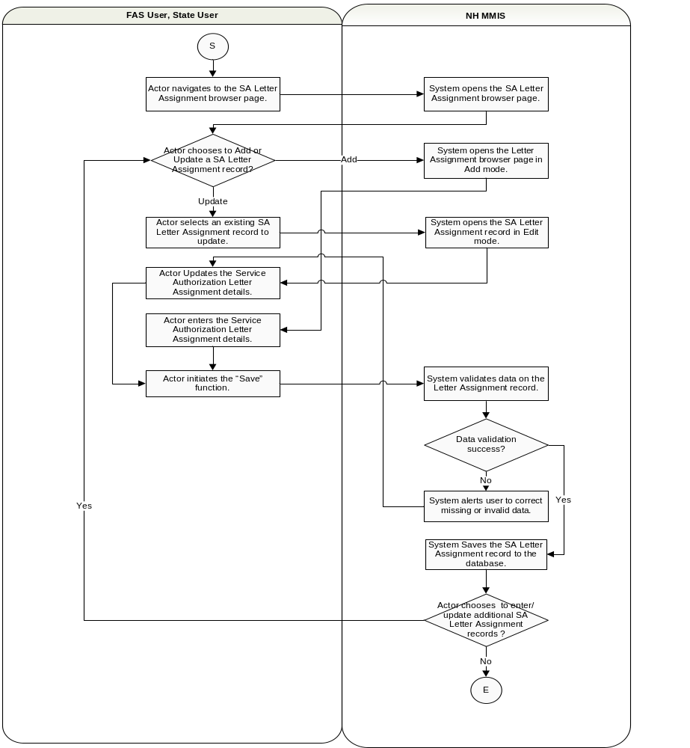

Browser Page Definition UIS-FIN-SRA-010.3- SA Letter Assignment
Portlet Name | UIS-FIN-SRA-010.3
Portlet Title | SA Letter Assignment
Description | The Service Authorization system includes functionality to trigger the creation of paper-based letters to providers, members and additional parties. The SA Letter Assignment browser page is used to define when letters are required, to whom they are sent and what letter template is used to create the letter.
Page | Service Authorization Letter Assignment
Navigation Map | Internal User Login → Rules Management → Service Authorization Letter Assignment.
Display by Default | N/A
Portlet Modes | (view | help)
Window States | (Minimized |maximized |normal).
Target Users | State User, FAS User, System
Backend System/Services | NH MMIS
Technical/Usability Requirements
Business Requirements
Notes

Browser Page Layout UIS-FIN-SRA-010.3 – SA Letter Assignment Display Filter
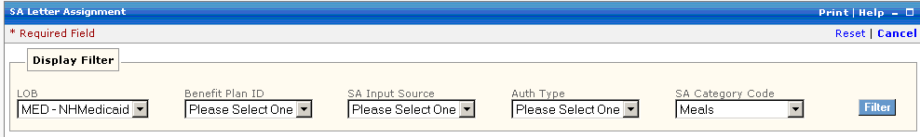

Browser Page Specification UIS-FIN-SRA-010.3 – SA Letter Assignment Display Filter
Description/ Label | Element Type | Req (A/C/N) | Protected (A/C/N) | Data Type | Max  Size | Table.Column | Specifications
Legend: A = Always C = Conditionally N = Never N/A = Not Applicable
LOB | Select Box | N | N | String |  | R_AUTH_LTR_ASGN_TB. R_LOB_CD | Line of Business  Read LOB Table
Benefit Plan ID | Select Box | N | N | String |  | R_AUTH_LTR_ASGN_TB. R_BP_ID | Benefit Plan ID  Read BP Table
SA Input Source | Select Box | N | N | String |  | R_AUTH_LTR_ASGN_TB.A_SRC_CD | The source of the original SA, e.g. Bridges, Options, etc.  A1-1011-A_SRC_CD
Auth Type | Select Box | N | N | String |  | R_AUTH_LTR_ASGN_TB. A_TY_CD | Service Authorization Type – Medical, Dental, DME and HCBC  A1-1012-A_TY_CD.
SA Category Code | Select Box | N | N | String |  | R_AUTH_LTR_ASGN_TB. A_CAT_SVC_CD | A sub-category of the Auth Type used for operational reporting, e.g. Manual Wheelchairs, Hospital Beds, etc.  A1-1249-A_LI_CAT_SVC_CD

Browser Page User Actions UIS-FIN-SRA-010.3 – SA Letter Assignment Display Filter
User Action | Type | Condition | Reaction
Reset | Button |  | Clears populated fields.
Cancel | Button |  | Cancels the transaction.
Filter | Button |  | Display SA Letter Assignment records based on filter criteria.

Browser Page Hover Text UIS-FIN-SRA-010.3 – SA Letter Assignment Display Filter
None identified for this process.

Browser Page Layout UIS-FIN-SRA-010.3 – SA Letter Assignment Summary Grid
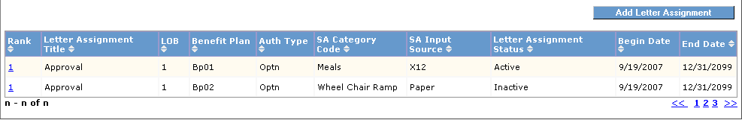

Browser Page Specification UIS-FIN-SRA-010.3 – SA Letter Assignment Summary Grid
Description/ Label | Element Type | Req (A/C/N) | Protected (A/C/N) | Data Type | Max Size | Table.Column | Specifications
Legend: A = Always C = Conditionally N = Never N/A = Not Applicable
Rank | Output | N/A | A | String | 6 | R_AUTH_LTR_ASGN_TB. R_RANK_SEQ_NUM | The rank number is used to determine the letter assignment record to use in the event that there are multiple matches.
Letter Assignment Title | Output | N/A | A | String | 30 | R_AUTH_LTR_ASGN_TB.A_LTR_ASGN_TITLE_DESC | This field describes the purpose of the Letter Assignment Record, e.g. “Options Denial Letter”. It is also used to reference the record in the future in case it needs to be revised.
LOB | Output | N/A | A | String | 3 | R_AUTH_LTR_ASGN_TB. R_LOB_CD | Line of Business
Benefit Plan | Output | N/A | A | String | 6 | R_AUTH_LTR_ASGN_TB. R_BP_ID | Benefit Plan ID
Auth Type | Output | N/A | A | String | 2 | R_AUTH_LTR_ASGN_TB. A_TY_CD | Service Authorization Type – Medical, Dental, DME and HCBC.
SA Category Code | Output | N/A | A | String | 3 | R_AUTH_LTR_ASGN_TB. A_CAT_SVC_CD | A sub-category of the Auth Type used for operational reporting, e.g. Manual Wheelchairs, Hospital Beds, etc.
SA Input Source | Output | N/A | A | String | 3 | R_AUTH_LTR_ASGN_TB.A_SRC_CD | The source of the original SA, e.g. Bridges Options, etc.
Letter Assignment Status | Output | N/A | A | String | 1 | R_AUTH_LTR_ASGN_TB.A_LTR_ASGN_STAT_CD | The Letter Assignment Status determines if letters should be produced. If set to inactive, the batch letter process will not use this SA Letter Assignment Status record to produce any letters.
Begin Date | Output | N/A | A | Date | 10 | R_AUTH_LTR_ASGN_TB.A_LTR_ASGN_BEG_DT | The Begin Date is the first effective date of the Letter Assignment Record.
End Date | Output | N/A | A | Date | 10 | R_AUTH_LTR_ASGN_TB.A_LTR_ASGN_END_DT | The End Date is the last effective date of the Letter Assignment Record.

Browser Page User Actions UIS-FIN-SRA-010.3 – SA Letter Assignment Summary Grid
User Action | Type | Condition | Reaction
Add Letter Assignment | Button |  | System expands the Add Letter Assignment portlet.
Rank | Button |  | Expands the Letter Assignment portlet to show the details for the row selected.

Browser Page Hover Text UIS-FIN-SRA-010.3 – SA Letter Assignment Summary Grid
None identified for this process.

Browser Page Layout UIS-FIN-SRA-010.3 – SA Letter Assignment – Add Letter Assignment
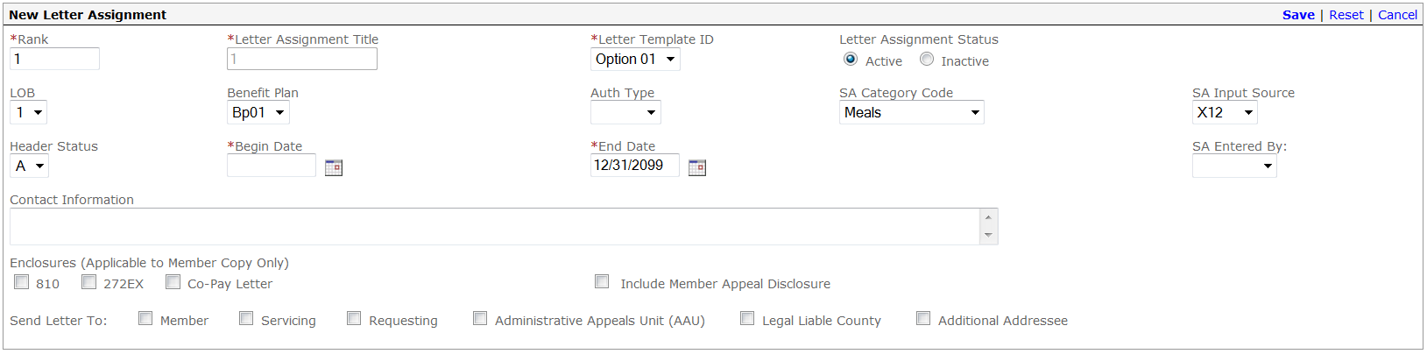

Browser Page Specification UIS-FIN-SRA-010.3 – SA Letter Assignment - Add Letter Assignment
Description/ Label | Element Type | Req (A/C/N) | Protected A/C/N) | Data Type | Max Size | Table.Column | Specifications
Legend: A = Always C = Conditionally N = Never N/A = Not Applicable
Rank | Text Box | A | N | String | 6 | R_AUTH_LTR_ASGN_TB.R_RANK_SEQ_NUM | The rank number is used to determine the letter assignment record to use in the event that there are multiple matches.  SRA2001.0116.01–  9-1060-0032
Letter Assignment Title | Text Box | A | N | String | 30 | R_AUTH_LTR_ASGN_TB.A_LTR_ASGN_TITLE_DESC | This field describes the purpose of the Letter Assignment Record, e.g. “Options Denial Letter”. It is also used to reference the record in the future in case it needs to be revised.
Letter Template ID | Select Box | A | N | String | 2 | R_AUTH_LTR_ASGN_TB.A_LTR_TY_CD | The ID of the template used to create the letters.  A1-0059-A_LTR_TY_CD
Letter Assignment Status | Radio Button | A | N |  | 1 | R_AUTH_LTR_ASGN_TB.A_LTR_ASGN_STAT_CD | The Letter Assignment Status determines if letters should be produced. If set to inactive, the batch letter process will not use this SA Letter Assignment Status record to produce any letters.
Active |  |  |  | String | N/A | N/A | Active is the default value.
Inactive |  |  |  | String | N/A | N/A | If the SA Letter Assignment Status is Inactive, no letters will be produced.
LOB | Select Box | N | N | String | 3 | R_AUTH_LTR_ASGN_TB.R_LOB_CD | Line of Business –Medicaid is the default value.  Read LOB Table
Benefit Plan | Select Box | N | N | String | 6 | R_AUTH_LTR_ASGN_TB.R_BP_CD | Benefit Plan ID  Read BP Table
Auth Type | Select Box | N | N | String | 2 | R_AUTH_LTR_ASGN_TB.A_TY_CD | Service Authorization Type – Medical, Dental, DME and HCBC.  A1-1012-A_TY_CD
SA Category Code | Select Box | N | N | String | 3 | R_AUTH_LTR_ASGN_TB.A_CAT_SVC_CD | A sub-category of the Auth Type used for operational reporting, e.g. Manual Wheelchairs, Hospital Beds, etc.  A1-1249-A_LI_CAT_SVC_CD
SA Input Source | Select Box | N | N | String | 3 | R_AUTH_LTR_ASGN_TB.A_SRC_CD | The source of the original SA, e.g. Bridges, Options, etc.  A1-1011-A_SRC_CD
Header Status | Select Box | N | N | String | 1 | R_AUTH_LTR_ASGN_TB.A_HDR_STAT_CD | SA Header Status  A1-1004-A_HDR_STAT_CD
Begin Date | Date Selector | A | N | Date | 10 | R_AUTH_LTR_ASGN_TB.A_LTR_ASGN_BEG_DT | The Begin Date is the first effective date of the Letter Assignment Record.  SRA2001.0117.01  9-1060-0033
End Date | Date Selector | A | N | Date | 10 | R_AUTH_LTR_ASGN_TB.A_LTR_ASGN_END_DT | The End Date is the last effective date of the Letter Assignment Record. SRA2001.0118.01  9-1060-0034
SA Entered By | Select Box | N | N | String | 30 | R_AUTH_LTR_ASGN_TB.A_LTR_ASGN_ENTRED_USER_ID | The User ID of the person who entered the SA.
Contact Information | Text Box | N | N | String | 80 | R_AUTH_LTR_ASGN_TB.A_CONTCT_INFO_TEXT | Optional letter content that tells the recipient of the letter who to contact if they have questions about the letter or SA.
Enclosures | Check Box | N | N | N/A | N/A | N/A | Supplemental documents that may be attached to the Member’s copy of SA letters.  Default is not checked. If any of these boxes are checked, then the field is protected. These enclosures are intended for Members only.
810 |  | N | N | String | 1 | R_AUTH_LTR_ASGN_ENCLSR_TB.A_ENCLSR_CD | The 810 form describes a Member’s appeal rights.
272 EX |  | N | N | String | 1 | R_AUTH_LTR_ASGN_ENCLSR_TB.A_ENCLSR_CD  Note: At the NH client’s request, this enclosure will not be operational at go-live. | This form describes the Member’s rights to an Administrative Review hearing.
Co-Pay Letter |  | N | N | String | 1 | R_AUTH_LTR_ASGN_ENCLSR_TB.A_ENCLSR_CD | This form describes the Co-Pay policy.
Include Member Appeal Disclosure | Check Box | N | N | String | 1 | R_AUTH_LTR_ASGN_TB.A_INCLD_APL_DSCLR_IND | Default is not checked. Checking this box will cause the appeal disclosure paragraph to be included in the body of the SA letter.
Send Letter To | Check Box | N/A | N/A | N/A | N/A | N/A | This is a list of people or agencies that will receive a copy of the letter. At least one box must be checked or a letter will not be produced. The default value is not checked.  SRA2001.0127.01  Error Message 9-1060-0117
Member |  | C | N | String | 1 | R_AUTH_LTR_ASGN_SEND_TO_TB.A_SEND_TO_CD | Member
Servicing |  | C | N | String | 1 | R_AUTH_LTR_ASGN_SEND_TO_TB.A_SEND_TO_CD | Servicing Provider
Requesting |  | C | N | String | 1 | R_AUTH_LTR_ASGN_SEND_TO_TB.A_SEND_TO_CD | Requesting Provider
Administrative Appeals Unit |  | C | N | String | 1 | R_AUTH_LTR_ASGN_SEND_TO_TB.A_SEND_TO_CD | Agency that handles SA appeals and clinical review proceedings.
Legal Liable County |  | C | N | String | 1 | R_AUTH_LTR_ASGN_SEND_TO_TB.A_SEND_TO_CD | The jurisdiction liable for payment for the services rendered.
Additional Addressee |  | C | N | String | 1 | R_AUTH_LTR_ASGN_SEND_TO_TB.A_SEND_TO_CD | All additional letter recipients (addressees) entered in the SA record.

Browser Page User Actions UIS-FIN-SRA-010.3 – Service Authorization Letter Assignment – Add Letter Assignment
User Action | Type | Condition | Reaction
Save | Link | Save Successful | Display message notifying user save was successful.
Save | Link | Save Failed | Show error message that save failed.
Reset | Button |  | Clears populated fields.
Cancel | Link |  | Cancels the transaction.

Browser Page Hover Text UIS-FIN-SRA-010.3 – Service Authorization Letter Assignment – Add Letter Assignment
None identified for this process.

Browser Page Layout UIS-FIN-SRA-010.3 – SA Letter Assignment – Edit Letter Assignment
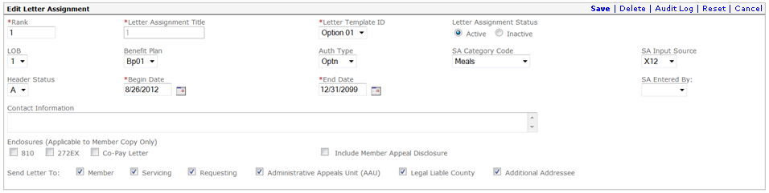

Browser Page Specification UIS-FIN-SRA-010.3 – SA Letter Assignment – Edit Letter Assignment
Description/ Label | Element Type | Req (A/C/N) | Protected (A/C/N) | Data Type | Max Size | Table.Column | Specifications
Legend: A = Always C = Conditionally N = Never N/A = Not Applicable
Rank | Text Box | A | C | String | 6 | R_AUTH_LTR_ASGN_TB.R_RANK_SEQ_NUM | The rank number is used to determine the letter assignment record to use in the event that there are multiple matches.  SRA2001.0116.01–  9-1060-0032
Letter Assignment Title | Text Box | A | C | String | 30 | R_AUTH_LGR_ASGN_TB.A_LTR_ASGN_TITLE_DESC | This field describes the purpose of the Letter Assignment Record, e.g. “Options Denial Letter”. It is also used to reference the record in the future in case it needs to be revised.
Letter Template ID | Select Box | A | C | String | 2 | R_AUTH_LTR_ASGN_TB.A_LTR_TY_CD | The ID of the template used to create the letters.  A1/0059- A_LTR_TY_CD
Letter Assignment Status | Radio Button | A | C | N/A | 1 | R_AUTH_LTR_ASGN_TB.A_LTR_ASGN_STAT_CD | The Letter Assignment Status determines if letters should be produced. If set to inactive, the batch letter process will not use this SA Letter Assignment Status record to produce any letters.
Active |  |  |  | String | N/A | N/A | Active is the default value.
Inactive |  |  |  | String | N/A | N/A | If the SA Letter Assignment Status is Inactive, no letters will be produced.
LOB | Select Box | N | C | String | 3 | R_AUTH_LTR_ASGN_TB.R_LOB_CD | Line of Business –Medicaid is the default value.
Benefit Plan | Select Box | N | C | String | 6 | R_AUTH_LTR_ASGN_TB.R_BP_CD | Benefit Plan ID
Auth Type | Select Box | N | C | String | 2 | R_AUTH_LTR_ASGN_TB.A_TY_CD | Service Authorization Type – Medical, Dental, DME and HCBC.  A1-1012-A_TY_CD
SA Category Code | Select Box | N | C | String | 3 | R_AUTH_LTR_ASGN_TB.A_CAT_SVC_CD | A sub-category of the Auth Type used for operational reporting, e.g. Manual Wheelchairs, Hospital Beds, etc.
SA Input Source | Select Box | N | C | String | 3 | R_AUTH_LTR_ASGN_TB.A_SRC_CD | The source of the original SA, e.g. Bridges, Options, etc.  A1-1249-A_LI_CAT_SVC_CD
Header Status | Select Box | N | C | String | 1 | R_AUTH_LTR_ASGN_TB.A_HDR_STAT_CD | SA Header Status  A1-1004-A_HDR_STAT_CD
Begin Date | Date Selector | A | C | Date | 10 | R_AUTH_LTR_ASGN_TB.A_LTR_ASGN_BEG_DT | The Begin Date is the first effective date of the Letter Assignment Record.  SRA2001.0117.01  9-1060-0033
End Date | Date Selector | A | C | Date | 10 | R_AUTH_LTR_ASGN_TB.A_LTR_ASGN_END_DT | The End Date is the last effective date of the Letter Assignment Record.  SRA2001.0118.01  9-1060-0034
SA Entered By | Select Box | N | C | String | 30 | R_AUTH_LTR_ASGN_TB.A_LTR_ASGN_ENTRED_USER_ID | The User ID of the person who entered the SA.
Contact Information | Text Box | N | C | String | 80 | R_AUTH_LTR_ASGN_TB.A_CONTCT_INFO_TEXT | Optional letter content that tells the recipient of the letter who to contact if they have questions about the letter or SA.
Enclosures | Check Box | N | N/A | N/A | N/A | N/A | Supplemental documents that may be attached to the Member’s copy of SA letters.  Default is not checked. If any of these boxes are checked, then the field is protected. These enclosures are intended for Members only.
810 |  | N | C | String | 1 | R_AUTH_LTR_ASGN_ENCLSR_TB.A_ENCLSR_CD | The 810 form describes a Member’s appeal rights.
272 EX |  | N | C | String | 1 | R_AUTH_LTR_ASGN_ENCLSR_TB.A_ENCLSR_CD  Note: At the NH client’s request, this enclosure will not be operational at go-live. | This form describes the Member’s rights to an Administrative Review hearing.
Co-Pay Letter |  | N | C | String | 1 | R_AUTH_LTR_ASGN_ENCLSR_TB.A_ENCLSR_CD | This form describes the Co-Pay policy.
Include Member Appeal Disclosure | Check Box | N | C | String | 1 | R_AUTH_LTR_ASGN_TB.A_INCLD_APL_DSCLR_IND | Default is not checked. Checking this box will cause the appeal disclosure paragraph to be included in the body of the SA letter.
Send Letter To | Check Box |  |  | N/A | N/A | N/A | This is a list of people or agencies that will receive a copy of the letter. At least one box must be checked or a letter will not be produced. The default value is not checked.  SRA2001.0127.01  Error Message 9-1060-0117
Member |  | C | C | String | 1 | R_AUTH_LTR_ASGN_SEND_TO_TB.A_SEND_TO_CD | Member
Servicing |  | C | C | String | 1 | R_AUTH_LTR_ASGN_SEND_TO_TB.A_SEND_TO_CD | Servicing Provider
Requesting |  | C | C | String | 1 | R_AUTH_LTR_ASGN_SEND_TO_TB.A_SEND_TO_CD | Requesting Provider
Administrative Appeals Unit |  | C | C | String | 1 | R_AUTH_LTR_ASGN_SEND_TO_TB.A_SEND_TO_CD | Agency that handles SA appeals and clinical review proceedings.
Legal Liable County |  | C | C | String | 1 | R_AUTH_LTR_ASGN_SEND_TO_TB.A_SEND_TO_CD | The jurisdiction liable for payment for the services rendered.
Additional Addressee |  | C | C | String | 1 | R_AUTH_LTR_ASGN_SEND_TO_TB.A_SEND_TO_CD | All additional letter recipients (addressees) entered in the SA record.

Browser Page User Actions UIS-FIN-SRA-010.3 – SA Letter Assignment – Edit Letter Assignment
User Action | Type | Condition | Reaction
Save | Button |  | Saves the changes to the letter assignment rule.
Reset | Button |  | Clears populated fields.
Delete | Button |  | Deletes the letter assignment rule.
Audit Log | Link |  | Displays standard audit portlet. Detailed descriptions and Use Case UC-GLB-SVC-01.1 – Global Audit Information Portlet Display - User ID & Timestamp and UC-GLB-SVC-02.1 - Audit Log Inquiry by Before & After Image can be found in Technical Requirements Chapter 27, Part A.
Cancel | Button |  | Cancels the transaction.

Browser Page Hover Text UIS-FIN-SRA-010.3 – SA Letter Assignment – Edit Letter Assignment
None identified for this process.

Use Case UC-OPR-SRA-020.1 - Service Auth Letters

Name
Service Auth Letters

ID
UC-OPR-SRA-020.1

Description
Service Authorizations are submitted for the determination of medical and dental necessity for Members enrolled in the NH Medicaid program. The NH Medicaid Program receives service authorization requests from providers through various channels such as mail, fax, phone, web, and electronic file transfers.
Service Authorization Records can be keyed into the NH MMIS system where the information is edited for validity and stored in the Service Authorization database. This Use Case describes the process of creating Service Authorization letters. Actors can also Add, Add Line Items, Search/ View, Update or Copy Service Authorization Records. These functions are covered in separate use cases.
Service Authorization letters are used to provide official notice of: service authorization status changes, changes to previously approved SA records, and to request additional information from providers. The MMIS Service Authorization (SA) system includes functionality to systematically produce Service Authorization letters to providers, members and additional parties as defined by the State. Letter generation is a two-step process. First, letter generation trigger records are created and stored in the Letter Trigger Table following certain events. Trigger events might include: adding a new SA record, updating an SA record, receiving an SA or SA update from a third party system, changing the approved units/dollars on a previously approved SA, or changing the header status of an SA record.
In the second step, which occurs on a scheduled basis, (e.g. nightly), the letter generation triggers are used to generate the actual SA letters based on the active Letter Assignment Records (see UC-OPR-SRA-020.2 – Service Authorization Letter Administration and UIS-FIN-SRA-010.3 Service Authorization Letter Assignment). The SA Letter Assignment record is used to define the criteria for determining if a letter is produced, the template used to produce the letter, supplemental enclosures, and to whom letters will be sent.
In addition to systematically generated letters, manual letters can be created by Actors in the Letters and Responses section at the bottom of the Service Authorization browser page.
Images of all previously sent Service Authorization letters are stored in EDMS. These letters can be viewed, printed and re-sent by authorized Actors.

Actors
NH MMIS System

Preconditions
The SA Letter Generation Batch Process is scheduled to run. Letter generation triggers have been created and saved to the Letter Trigger Table.

Trigger
The system initiates the scheduled batch process to generate SA letters.
Post Conditions
Service Authorization letters are successfully produced by merging letter content and letter templates based on the criteria defined in the active SA Letter Assignment records. Letter triggers are deleted from the Letter Trigger Table after they are used to create letters. System produces batch activity reports.

Basic Flow of Events – System Creates SA Letters
Step# | Actor Action | System Response | Related Artifacts (list IDs) | Step Remarks
1 | System initiates the SA Letter Generation Batch Process. | System reads the active Service Authorization Letter Assignment records and saves the letter assignment variables.  Exception Flow #1 applies to all steps of the Basic Flow. | UC-OPR-SRA-020.2  UIS-FIN-SRA-010.3
2 |  | System reads a row of the Letter Trigger Table.  See Alternate Flow #2 | SRA2001.2256.01 | Processing only Triggers with Type = "LTR"
3 |  | System reads the Service Authorization record details.
4 |  | System determines that a SA Letter is needed for the SA based on the active Service Authorization Letter Assignment records.  See Alternate Flow #1 | UC-OPR-SRA-020.2  UIS-FIN-SRA-010.3  Business Rules:  SRA2001.0109.01  SRA2001.1153.01  SRA2001.1807.01  SRA2001.1970.01  SRA2001.1018.01  SRA2001.1934.01  SRA2001.3031.01  PL-OPR-SRA-001 SA Letter Assignment Data Explained
5 |  | System extracts additional data from the Provider, Member and Reference Tables.
6 |  | System determines the appropriate letter template and any supplemental attachments required (i.e. the form 810 for SA denial letters).  See Alternate Flow #3 | UC-OPR-SRA-020.2  UIS-FIN-SRA-010.3  Business Rules:  SRA2001.1152.01 SRA2001.1923.01  SRA2001.1941.01  SRA2001.2397.01
7 |  | The system passes the Letter Template ID and letter content to the letter generation COTS application. | PL-OPR-SRA-004 SA Letter BO  SRA2001.301.01  SRA2001.3014.02 | Note: The system produces copies of the letter for all additional letter recipients.
8 |  | The system retains the free form text in the Comment Table, then deletes all supplemental letter comments and free form Text from the SA record. | SRA2001.2064.01  SRA2001.3036.01
9 |  | The system deletes the row from the Letter Trigger Table.
10 |  | The system continues with step #2 until all Trigger table rows have been processed.
11 |  | System produces batch activity reports.  System Use Case Ends.

Alternate Flow 1- Trigger does not match any SA Letter Assignment Criteria
Step # | Basic Flow Step # | Actor Action | System Response | Related Artifacts (list IDs) | Step Remarks
1 | 4 |  | System determines that a SA Letter is not needed for the SA based on the active Service Authorization Letter Assignment records.  The process continues at Step #10 of the Basic Flow. | UC-OPR-SRA-020.2  UIS-FIN-SRA-010.3

Alternate Flow 2 — Trigger Type is not for Letters
Step# | Basic Flow Step # | Actor Action | System Response | Related Artifacts (list IDs) | Step Remarks
1 | 2 |  | System determines that the Trigger Type is not for Letters.  The process continues at Step #2 of the Basic Flow. | UC-FIN-SRA-020.2  UIS-FIN-SRA-010.3 | Trigger row not deleted
Alternate Flow 3 — No Receiver Information Available
Step# | Basic Flow Step # | Actor Action | System Response | Related Artifacts (list IDs) | Step Remarks
1 | 6 |  | System determines that no Receiver info is available to send letter to.  The process continues at Step #2 of the Basic Flow. | UC-FIN-SRA-020.2  UIS-FIN-SRA-010.3

Exception Flow 1 – System Failure
Step # | Basic Flow Step # | Actor Action | System Response | Related Artifacts (list IDs) | Step Remarks
1 | All | The system encounters failure. | FAS staff resolves the issue and restarts the process.  System returns Control to Basic Flow Step 1. | Error Message:  9-0000-0110

Activity Diagram UC-OPR-SRA-020.1 - Service Auth Letters
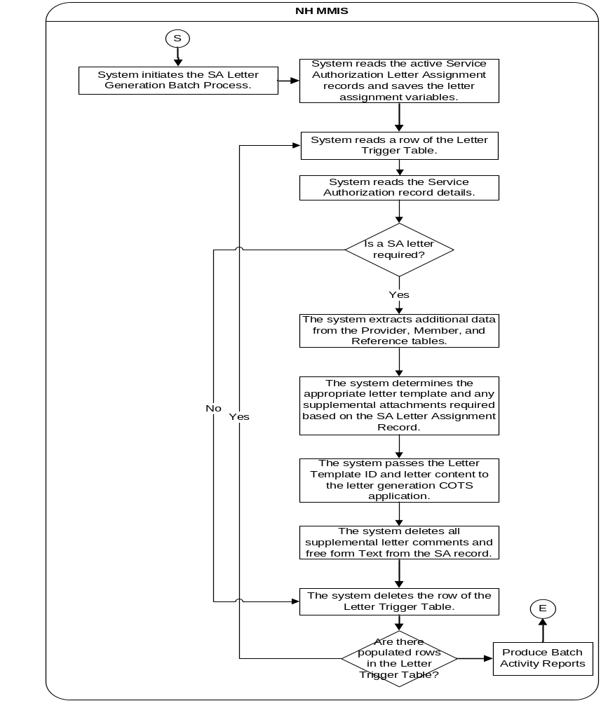

Report Definition
None identified for this process.

Letter Definition OPR-SA-L001 Service Authorization Notification
Letter Name | Template ID | Use Case ID | Supervisor Review Required? | Letter Short Description
Service Authorization Notification | OPR-SA-L001 | UC-OPR-SRA-020.1 | No | Service Authorization Notification Letter: This letter summarizes the results of a service authorization review.

Service Authorization Notification: Letter Definition
Service Authorization Notification: Letter Definition
Letter Type: |  Standard  Customized (Adhoc) | Enterprise  New Hampshire
Customer Name: | State of New Hampshire
Customer Letter ID: | OPR-SA-L001
Prepared By: | Judith Cozart/Craig Heyrman/Kim Metzer
Reviewed and Approved By:
Functional Lead: | Craig Heyrman
Letter PM: | Mike King
Letter Generation Lead: | Cassandra Morgan
SME: | Andy Fontalbert
Customer Line of Business: | Medicaid
Letter Source State Code: | NH
Letter Source Type: | ☑OLTP (Default) | OLAP
Customer Division/Department: | Provider  Member  Program | Operations:  Case Management   Acuity  Claims | TPL  EPSDT  County Billing  Web Portal | SURS  ☑Service Authorization  Care Management  Ad hoc Reporting

Service Authorization Notification: Letter Detailed Definition
Service Authorization Notification: Letter Detailed Definition
Letter Calendar Type: | State Fiscal  (July – June) | Federal Fiscal  (October – September) | Calendar Days:   Regular  (January – December)  Business  (Monday – Friday exclude weekends/holidays) | N/A
Letter Frequency Type: | Scheduled  On Request | If scheduled, select timeframe below:  Daily  Weekly  Monthly  Quarterly  Annually | ☑Other — Please Explain: The Letters for a particular SA are produced as a result of changes to the SA record. The SA letter batch process will be scheduled to run on a daily basis.
Letter Selection Criteria:  Indicates the parameters used in extracting the data for the letter. | Selection Field |  | Selection Field Values
 | This letter is produced via a batch process (described in UC-OPR-SRA-020.1 – Service Auth Letters) based on the parameters defined in the SA Letter Assignment records (see UC-OPR-SRA-020.2 SA Letter Administration and UIS-FIN-SRA-010.3 – SA Letter Assignment).
Letter Output Format: | ☑PDF (preferred) | HTML
Letter Distribution Method: | ☑ Mail  ☑Inbox | Override Preferred Delivery Method  Yes  ☑No | ☑EDMS (Default)
State Point of Contact: | Pam Smith – OIT |  | Phone: (603) 223-4768
Vendor Point of Contact: | Craig Heyrman |  | Phone: (770) 829-1552
Letter Dependencies (Optional): | During letter generation the G_COTS_LTR_REQ_RECR_TB.G_LTR_REQ_COMMUN_MTHD_CD is populated for letter recipients as detailed below. If recipient is a Provider, the P_RA_MEDM_TB.P_RA_MEDM_CD is read to populate this field. (If the P_RA_MEDM_CD is not equal ‘1-Paper’ set code to ‘I-Inbox’; else Set code to ‘M-Mailbox’.  After this letter PDF (complete file which contains all TO and CC’s) is generated and stored in EDMS, it is then copied and delivered to recipients as detailed in the G_COTS_LTR_REQ_RECR_TB.G_LTR_REQ_COMMUN_MTHD_CD, detailed below:  • If a To or Cc recipient has a G_LTR_REQ_COMMUN_MTHD_CD of 'M', their letter will be sent to the Print Vendor for mailing.  Note: A Member Cc G_LTR_REQ_COMMUN_MTHD_CD will always be 'M' and sent to Print Vendor for printing.  • If a To or Cc Provider recipient has a G_LTR_REQ_COMMUN_MTHD_CD of 'I'(nbox), their letter will be sent to their Provider Web Inbox.  Letter file contents:  • EDMS  ▪ A complete PDF file containing all letters for To/cc’d recipients will be stored in the Doc Repository.  • Inbox  ▪ A complete PDF file containing all letters for To/cc’d recipients will be delivered to their Provider Message Center (Inbox) using an EDMSTriggerIndicator = ‘S’  • Mail/Print Vendor  ▪ To Provider recipient – receives copy of letter plus applicable attachments.  ▪ Cc’d Member Recipient receives cover sheet containing their address and copy of letter plus applicable attachments.  ▪ Cc’d Provider recipient (if different from To recipient) receives cover sheet containing their address and copy of letter plus applicable attachments.
Letter Generation Languages: | ☑English | Spanish | Both | Front English, Back Spanish
Letter Generation Pagination | Single Page | Multipage
Letter Generation Free Form Text (Optional) | ☑Yes | No
Letter Special Processing | SA letters are produced based on the rules defined in the SA Letter Assignment records.  Letters will be printed two-sided if multiple pages.  If the Service Authorization Detail requires more than one page, the entire page will be used for all subsequent pages.

Service Authorization Notification: Letter Layout


NEW HAMPSHIRE TITLE XIX MEDICAID PROGRAM

SERVICE AUTHORIZATION NOTIFICATION

Medicaid Director
Medicaid Director

<Letter Date>

<Send To Name>
<Send To Address Line 1>
<Send To Address Line 2>
<Send To Address City>, < Send To Address State> <Send To Address Zip Code>-<Send To Address Zip Code +4>

RE: Member Name: <Mem First Name> <Mem MI> <Mem Last Name>
Member ID: <Member ID>
Service Authorization ID: <SA ID>

The Service Authorization noted above has been reviewed and the results of this review are documented in the following Service Authorization Detail.

Additional Reviewer Comments:
<Comment 1:>
<Comment 2:>
<Comment 3:>
<Comment 4:>
<Comment 5:>
<Text:>
Service Authorization Notification
OPR-SA-L001

<Letter Date>
Page 33
<Member Last Name>

<Contact Information>

<Member Appeal Information: You may appeal this decision now. You have 30 calendar days of the date on this letter to file your appeal. You may represent yourself or be represented by others, including legal counsel, at a fair hearing. The NH Medicaid Program will not pay for your legal fees. To request a fair hearing, please contact the Office of Administrative Appeals at: 800-852-3345, Ext. 4292 (in state only) or 603-271-4292. >

Enclosure(s):
<Enclosure>
Cc: <List all other letter recipients>

Service Authorization Notification
OPR-SA-L001
<Letter Date>
Page 3
<Member Last Name>

NEW HAMPSHIRE TITLE XIX MEDICAID PROGRAM
SERVICE AUTHORIZATION DETAIL
Note: The table below will display a maximum of 3 SA Line Items per 8 ½” X 11” page
Member ID: <Member ID>  Member Name: <Mem First Name> <Mem MI> <Mem Last Name>  Service Authorization ID: <SA_ID> |  | Requesting Provider Name: <Req Prov Name>  Header Status: <Hdr_Stat_Cd>
Service Authorization Line Item Number | <SA_LineNum> | <SA_LineNum> | <SA_LineNum>
Servicing Provider Name | <S_Provider_Name> | <S_Provider_Name> | <S_Provider_Name>
Status | <Status> | <Status> | <Status>
Explanation for Status Change | <Status _Desc> | <Status _Desc> | <Status _Desc>
Approved Begin Date | <Beg_Date> | <Beg_Date> | <Beg_Date>
Approved End Date | <End_Date> | <End_Date> | <End_Date>
Service Code | <Service_Code> | <Service_Code> | <Service_Code>
Service Description | <Service_Desc> | <Service_Desc> | <Service_Desc>
Modifier 1 | <Modifier1> | <Modifier1> | <Modifier1>
Modifier 2 | <Modifier2> | <Modifier2> | <Modifier2>
Modifier 3 | <Modifier3> | <Modifier3> | <Modifier3>
Modifier 4 | <Modifier4> | <Modifier4> | <Modifier4>
Service Code (end of range if applicable) | <Service_Code> | <Service_Code> | <Service_Code>
Service Description | <Service_Desc> | <Service_Desc> | <Service_Desc>
Approved Units | <App_Units> | <App_Units> | <App_Units>
Approved Amount | <App_Amt> | <App_Amt> | <App_Amt>
Approved Rate/Unit | <App_Rate> | <App_Rate> | <App_Rate>
Approved Frequency | <App_Freq> | <App_Freq> | <App_Freq>

Service Authorization Notification
OPR-SA-L001
<Letter Date>
Page 4
<Member Last Name>

Tooth Number | <Tooth_Num> | <Tooth_Num> | <Tooth_Num>
Dental Quadrant | <Dental_Quad> | <Dental_Quad> | <Dental_Quad>
Tooth Surface 1 | <Tooth_Surface1> | <Tooth_Surface1> | <Tooth_Surface1>
Tooth Surface 2 | <Tooth_Surface2> | <Tooth_Surface2> | <Tooth_Surface2>
Tooth Surface 3 | <Tooth_Surface3> | <Tooth_Surface3> | <Tooth_Surface3>
Tooth Surface 4 | <Tooth_Surface4> | <Tooth_Surface4> | <Tooth_Surface4>
Tooth Surface 5 | <Tooth_Surface5> | <Tooth_Surface5> | <Tooth_Surface5>
Last Updated Date | <Last_Upd_Date> | <Last_Upd_Date> | <Last_Upd_Date>

MEDICAID ELIGIBILITY DISCLAIMER: This form is notification of the approved service, the proper billing codes, units of service, rate of payment, and authorization number to be used upon submission of claim. The member’s Medicaid eligibility must be checked prior to providing any medical services for valid eligibility dates and possible third party insurance coverage.

Service Authorization Notification
OPR-SA-L001

Service Authorization Notification: Letter Specification
Service Authorization Notification: Letter Specification
Letter Section Heading
Letter Section Logo (Required): | Letter Section Description (Optional):
Seal of the State of NH | NEW HAMPSHIRE TITLE XIX MEDICAID PROGRAM  SERVICE AUTHORIZATION NOTIFICATION
Detail page (This is a header) | NEW HAMPSHIRE TITLE XIX MEDICAID PROGRAM  SERVICE AUTHORIZATION DETAIL

Letter Salutation
Field Type | Business Label | Field Description |  | Source Table | Source Column and Keyword | Source Column Processing Rules
None
Letter Body
DATE | Letter Date |  | Date letter is generated | G_COTS_LTR_REQ_TB | G_TO_BE_SENT_DT | The date the letter was produced via the batch process.
VARCHAR | Send To Name |  | Send To Name. | For Providers (Servicing, Requesting):  P_DTL_TB  For Member:  B_DTL_TB  For Administrative Appeals Unit:  G_SPEC_ENTY_TB  For Legal Liable County:  G_SPEC_ENTY_TB  For Additional Addressee:  G_SPEC_ENTY_TB | P_NAM  B_LAST_NAM, B_FIRST_NAM, B_MID_NAM, B_SFX_NAM  G_ORG_NAM  G_ORG_NAM  G_LAST_NAM, G_FIRST_NAM, G_MID_NAM, G_SFX_NAM | This is the name based on what was checked on the SA Letter Assignment record.  Ruleset for Member:  MEM4007.2020.NH01
VARCHAR | Send To Address Line 1 |  | Send To address line 1. | G_ADR_TB | G_LINE1_ADR | This is the address based on what was checked on the SA Letter Assignment record.
VARCHAR | Send To Address Line 2 |  | Send To address line 2. | G_ADR_TB | G_LINE2_ADR | This is the address based on what was checked on the SA Letter Assignment record.
VARCHAR | Send To Address City |  | Send To city. | G_ADR_TB | G_CITY_NAM | This is the address based on what was checked on the SA Letter Assignment record.
VARCHAR | Send To Address State |  | Send To state. | G_ADR_TB | G_US_STATE_CD | This is the address based on what was checked on the SA Letter Assignment record.
VARCHAR | Send To Address Zip Code |  | Send To zip code. | G_ADR_TB | G_ZIP5_CD | This is the address based on what was checked on the SA Letter Assignment record.
VARCHAR | Send To Address Zip Code + 4 |  | Send To zip code + 4 | G_ADR_TB | G_ZIP4_CD | This is the address based on what was checked on the SA Letter Assignment record.
VARCHAR | Mem First Name |  | Member first name. | B_DTL_TB | B_FIRST_NAM | Do not print if Member is invalid (no B-SYS-ID)
VARCHAR | Mem MI |  | Member middle initial. | B_DTL_TB | B_MID_NAM | Do not print if Member is invalid (no B-SYS-ID)  Format by capitalizing the first letter followed by a period. For example, John T. Doe
VARCHAR | Mem Last Name |  | Member last name. | B_DTL_TB | B_LAST_NAM | Do not print if Member is invalid (no B-SYS-ID)
VARCHAR | Member ID |  | Member ID. | A_HDR_TB | A_SUBM_MBR_ALT_ID | Do not print if Member is invalid (no B-SYS-ID)
VARCHAR | SA ID |  | Internal Service Authorization ID. | A_HDR_TB | A_AUTH_ID
VARCHAR | Comment 1 |  | Comment 1 | G_COTS_LTR_REQ_PARAM_TB | G_TEXT
VARCHAR | Comment 2 |  | Comment 2 | G_COTS_LTR_REQ_PARAM_TB | G_TEXT
VARCHAR | Comment 3 |  | Comment 3 | G_COTS_LTR_REQ_PARAM_TB | G_TEXT
VARCHAR | Comment 4 |  | Comment 4 | G_COTS_LTR_REQ_PARAM_TB | G_TEXT
VARCHAR | Comment 5 |  | Comment 5 | G_COTS_LTR_REQ_PARAM_TB | G_TEXT
VARCHAR | Text |  | Text | G_COTS_LTR_REQ_PARAM_TB | G_TEXT
VARCHAR | Contact Information |  | Contact Information | R_AUTH_LTR_ASGN_TB. | A_CONTCT_INFO_TEXT | Defined in the Letter Assignment record.
VARCHAR | Appeal Information |  | Appeal Information | R_AUTH_LTR_ASGN_TB. | A_INCLD_APL_DSCLR_IND | Defined in the Letter Assignment record.
VARCHAR | Enclosure |  | Enclosure | R_AUTH_LTR_ASGN_ENCLR_TB | A_ENCLSR_CD | Defined in the Letter Assignment record.  Additionally, Partially Denied Authorizations have an 810 automatically appended:  If A_HDR_TB.A_HDR_STAT_CD = "A-Approved"  AND [the following is TRUE for ANY detail line] (A_DTL_TB.A_LI_STAT_CD = 'D-Denied')  OR  (A_DTL_TB.A_LI_APP_UNIT_AMT is less than A_DTL_TB.A_LI_REQ_UNIT_AMT  THEN  Enclosure 810 is printed.
VARCHAR | Cc |  | Cc | R_AUTH_LGR_ASGN_SEND_TO_TB | A_SEND_TO_CD | Defined in the Letter Assignment record.
Letter Detail
VARCHAR | Member ID |  | Member ID. | A_HDR_TB | A_SUBM_MBR_ALT_ID | Do not print if Member is invalid (no B-SYS-ID)
VARCHAR | Mem First Name |  | Member first name. | B_DTL_TB | B_FIRST_NAM | Do not print if Member is invalid (no B-SYS-ID)
VARCHAR | Mem MI |  | Member middle initial. | B_DTL_TB | B_MID_NAM | Do not print if Member is invalid (no B-SYS-ID)  Format by capitalizing the first letter followed by a period. For example, John T. Doe
VARCHAR | Mem Last Name |  | Member last name. | B_DTL_TB | B_LAST_NAM | Do not print if Member is invalid (no B-SYS-ID)
VARCHAR | SA ID |  | Internal Service Authorization ID. | A_HDR_TB | A_AUTH_ID
VARCHAR | Req_Prv_Name |  | Requesting Provider Last Name. | P_DTL_TB | P_NAM
VARCHAR | Hdr_Status |  | Header Status | A_HDR_TB | A_HDR_STAT_CD
NUMERIC | SA_LineNum |  | Service Authorization Line Number. | A_DTL_TB | A_LI_NUM
VARCHAR | S_Provider_Name |  | Servicing Provider Name. | P_DTL_TB | P_NAM
VARCHAR | Status |  | Status | A_DTL_TB | A_LI_STAT_CD
VARCHAR | Status_Desc |  | Explanation for Status Change. | A_DTL_TB | A_RSN_CD
DATE | Beg_Date |  | Approved Begin Date. | A_DTL_TB | A_LI_BEG_DT
DATE | End_Date |  | Approved End Date. | A_DTL_TB | A_LI_END_DT
VARCHAR | Service Code |  | Service Code. | A_DTL_TB | A_LI_SVC_FROM_CD
VARCHAR | Service_Desc |  | Service Description. | R_PROC_TB | R_PROC_SHORT_DESC
VARCHAR | Modifier1 |  | Modifier. | A_DTL_TB | R_PROC_MOD_1ST _CD
VARCHAR | Modifier2 |  | Modifier. | A_DTL_TB | R_PROC_MOD_2ND _CD
VARCHAR | Modifier3 |  | Modifier. | A_DTL_TB | R_PROC_MOD_3RD _CD
VARCHAR | Modifier4 |  | Modifier. | A_DTL_TB | R_PROC_MOD_4TH _CD
VARCHAR | Service_Code |  | Service Code. | A_DTL_TB | A_LI_SVC_THRU_CD
VARCHAR | Service_Desc |  | Service Description. | R_PROC_TB | R_PROC_SHORT_DESC
NUMERIC | App_Units |  | Approved Units. | A_DTL_TB | A_LI_APP_UNIT_AMT
DECIMAL | App_Amt |  | Approved Amount. | A_DTL_TB | A_LI_APP_AMT
DECIMAL | App_Rate |  | Approved Rate/Unit. | A_DTL_TB | A_LI_APP_RATE_AMT
VARCHAR | App_Freq |  | Approved Frequency. | A_DTL_TB | A_LI_APP_PRD_CD
NUMERIC | Tooth_Num |  | Tooth Number. | A_DTL_TOOTH_TB | A_LI_R_PROC_TOOTH_CD | Note: Only the first Tooth Number on each SA Line Item will be included in the letter.
ALPHANUMERIC | Dental_Quad |  | Dental Quadrant. | A_DTL_TB | R_PROC_ORAL_CAV_CD | Note: Only the first Dental Quadrant on each SA Line Item will be included in the letter.
ALPHANUMERIC | Tooth_Surface 1 |  | Tooth Surface. | A_DTL_TOOTH_TB | A_LI_TOOTH_1ST_SURF_CD
ALPHANUMERIC | Tooth_Surface 2 |  | Tooth Surface. | A_DTL_TOOTH_TB | A_LI_TOOTH_2ND_SURF_CD
ALPHANUMERIC | Tooth_Surface 3 |  | Tooth Surface. | A_DTL_TOOTH_TB | A_LI_TOOTH_3RD_SURF_CD
ALPHANUMERIC | Tooth_Surface 4 |  | Tooth Surface. | A_DTL_TOOTH_TB | A_LI_TOOTH_4TH_SURF_CD
ALPHANUMERIC | Tooth_Surface 5 |  | Tooth Surface. | A_DTL_TOOTH_TB | A_LI_TOOTH_5TH_SURF_CD
DATE | Last_Upd_Date |  | Last Updated Date. | A_DTL_TB | G_AUD_TS
VARCHAR | Medicaid Director |  | Medicaid Director | R_PARAM_DTL_TB | R_PARAM_VALUE_DATA | Processing: Match  R_PARAM_DTL_TB.R_PARAM_VALUE_DATA where R_FUNC_AREA_CD = ‘A1’ and R_PARAM_NUM = 37
Free Form Text (Optional)
Letter Closing
Field Type | Business Label
Letter Footer Contents
 |  | Letter Multipage (Required): i.e., 1 of 1 or 1 of 2: |  |  |  |  | Letter Template ID (Required):
 |  | 1 of 2  Letters will be printed two-sided if multiple pages. |  |  |  |  | Service Authorization Notification  OPR-SA-L001

Letter Definition OPR-SA-L002 - Request for Additional Information
Letter Name | Template ID | Use Case ID | Supervisor Review Required? | Letter Short Description
Request for Additional Information | OPR-SA-L002 | UC-OPR-SRA-020.1 | No | Request for Additional Information Letter: This letter is a request for additional information needed before a final decision can be made for a Service Authorization request.

Request for Additional Information: Letter Definition
Request for Additional Information: Letter Definition
Letter Type: |  Standard  Customized (Adhoc) | Enterprise  New Hampshire
Customer Name: | State of New Hampshire
Customer Letter ID: | OPR-SA-L002
Prepared By: | Judith Cozart/ Craig Heyrman/Kim Metzer
Reviewed and Approved By:
Functional Lead: | Craig Heyrman
Letter PM: | Mike King
Letter Generation Lead: | Cassandra Morgan
SME: | Andy Fontalbert
Customer Line of Business: | Medicaid
Letter Source State Code: | NH
Letter Source Type: | ☑OLTP (Default) | OLAP
Customer Division/Department: | Provider  Member  Program | Operations:  Case Management   Acuity  Claims | TPL  EPSDT  County Billing  Web Portal | SURS  ☑Service Authorization  Care Management  Ad hoc Reporting

Request for Additional Information: Letter Detailed Definition
Request for Additional Information: Letter Detailed Definition
Letter Calendar Type: | State Fiscal  (July – June) | Federal Fiscal  (October – September) | Calendar Days:   Regular  (January – December)  Business  (Monday – Friday exclude weekends/holidays) | N/A
Letter Frequency Type: | Scheduled  On Request | If scheduled, select timeframe below:  Daily  Weekly  Monthly  Quarterly  Annually | ☑Other — Please Explain: The Letters for a particular SA are produced as a result of changes to the SA record. The SA letter batch process will be scheduled to run on a daily basis.
Letter Selection Criteria:  Indicates the parameters used in extracting the data for the letter. | Selection Field |  | Selection Field Values
 | This letter is produced via a batch process (described in UC-OPR-SRA-020.1 – Service Auth Letters) based on the parameters defined in the SA Letter Assignment records (see UC-OPR-SRA-020.2 SA Letter Administration and UIS-FIN-SRA-010.3 – SA Letter Assignment).
Letter Output Format: | ☑PDF (preferred) | HTML
Letter Distribution Method: | ☑ Mail  ☑ Inbox | Override Preferred Delivery Method   Yes  ☑ No | ☑ EDMS (Default)
State Point of Contact: | Pam Smith – OIT |  | Phone: (603) 223-4768
Vendor Point of Contact: | Craig Heyrman |  | Phone: (770) 829-1552
Letter Dependencies (Optional): | During letter generation the G_COTS_LTR_REQ_RECR_TB.G_LTR_REQ_COMMUN_MTHD_CD is populated for letter recipients as detailed below. If recipient is a Provider, the P_RA_MEDM_TB.P_RA_MEDM_CD is read to populate this field. (If the P_RA_MEDM_CD is not equal ‘1-Paper’ set code to ‘I-Inbox’; else Set code to ‘M-Mailbox’.  After this letter PDF (complete file which contains all TO and CC’s) is generated and stored in EDMS, it is then copied and delivered to recipients as detailed in the G_COTS_LTR_REQ_RECR_TB.G_LTR_REQ_COMMUN_MTHD_CD, detailed below:  • If a To or Cc recipient has a G_LTR_REQ_COMMUN_MTHD_CD of 'M', their letter will be sent to the Print Vendor for mailing.  Note: A Member Cc G_LTR_REQ_COMMUN_MTHD_CD will always be 'M' and sent to Print Vendor for printing.  • If a To or Cc Provider recipient has a G_LTR_REQ_COMMUN_MTHD_CD of 'I'(nbox), their letter will be sent to their Provider Web Inbox.  Letter file contents:  • EDMS  ▪ A complete PDF file containing all letters for To/cc’d recipients will be stored in the Doc Repository.  • Inbox  ▪ A complete PDF file containing all letters for To/cc’d recipients will be delivered to their Provider Message Center (Inbox) using an EDMSTriggerIndicator = ‘S’  • Mail/Print Vendor  ▪ To Provider recipient – receives copy of letter plus applicable attachments.  ▪ Cc’d Member Recipient receives cover sheet containing their address and copy of letter plus applicable attachments.  ▪ Cc’d Provider recipient (if different from To recipient) receives cover sheet containing their address and copy of letter plus applicable attachments.
Letter Generation Languages: | ☑English | Spanish | Both | Front English, Back Spanish
Letter Generation Pagination | Single Page | Multipage
Letter Generation Free Form Text (Optional) | ☑Yes No
Letter Special Processing | SA letters are produced based on the rules defined in the SA Letter Assignment records.  Letters will be printed two-sided if multiple pages.  If the Service Authorization Detail requires more than one page, the entire page will be used for all subsequent pages.
  Print header info and static left-hand column on all pages, if more than one page is needed.
  Index Values
  Code | Desc
  83 | CMTempID
  84 | CMTempNam
  4 | Member Medicaid ID
  8 | Service Authorization Number

Letter Special Processing
  Issue # | Issue | Decision
  1 | Left Margin | 0.5 inch (one-half inch margin)
  2 | Right Margin | 0.5 inch (one-half inch margin)
  3 | Top Margin | From the top rim of the State Seal to the top piece of paper = 0.5 inch (one-half inch margin)
  4 | Bottom Margin | 1 inch from the bottom of the page. The last line of static text should be 1 inch from bottom of page.
  5 | State Seal logo | 1 inch in diameter
  6 | Vendor Logo | 1 inch in diameter
  7 | Footer (barcode and template id) | Footer includes the barcode and letter ID and both should be aligned horizontally and fit within the bottom margin

Request for Additional Information: Letter Layout

NEW HAMPSHIRE TITLE XIX MEDICAID PROGRAM
Medicaid Director REQUEST FOR ADDITIONAL INFORMATION

<Letter Date>

<Send Letter To Name>
<Send Letter To Address Line 1>
<Send Letter To Address Line 2>
<Send Letter To Address City>, < Send Letter To Address State> < Send Letter To Address Zip Code>-< Send Letter To Address Zip Code +4>

RE: Member Name: <Mem First Name> <Mem MI> <Mem Last Name>
Member ID: <Member ID>
Service Authorization ID: <SA ID>

The Service Authorization noted above has been reviewed and additional information is needed before a final decision can be made. Please read the additional reviewer comments below, as well as the Service Authorization Detail for more specific information.

Additional Reviewer Comments:
<Comment 1:>
<Comment 2:>
<Comment 3:>
<Comment 4:>
<Comment 5:>
<Text:>

<Contact information>

Enclosure(s):
<Enclosure>
Cc: <List all other letter recipients>

Request for Additional Information
OPR-SA-L002
<Letter Date> <Letter Date>
Page 47
<Member Last Name>

NEW HAMPSHIRE TITLE XIX MEDICAID PROGRAM
SERVICE AUTHORIZATION DETAIL
Note: The table below will display a maximum of 3 SA Line Items per 8 ½” X 11” page.
Member ID: <Member ID>  Member Name: <Mem First Name> <Mem MI>  <Mem Last Name>  Service Authorization ID: <SA_ID> |  |  | Requesting Provider Name: <Req Prov Name>  Header Status: <Hdr_Status>
Service Authorization Line Item Number | <SA_LineNum> | <SA_LineNum> |  | <SA_LineNum>
Servicing Provider Name | <S_Provider_Name> | <S_Provider_Name> |  | <S_Provider_Name>
Status | <Status> | <Status> |  | <Status>
Explanation for Status Change | <Status _Desc> | <Status _Desc> |  | <Status _Desc>
Approved Begin Date | <Beg_Date> | <Beg_Date> |  | <Beg_Date>
Approved End Date | <End_Date> | <End_Date> |  | <End_Date>
Service Code | <Service_Code> | <Service_Code> |  | <Service_Code>
Service Description | <Service_Desc> | <Service_Desc> |  | <Service_Desc>
Modifier 1 | <Modifier1> | <Modifier1> |  | <Modifier1>
Modifier 2 | <Modifier2> | <Modifier2> |  | <Modifier2>
Modifier 3 | <Modifier3> | <Modifier3> |  | <Modifier3>
Modifier 4 | <Modifier4> | <Modifier4> |  | <Modifier4>
Service Code (end of range if applicable) | <Service_Code> | <Service_Code> |  | <Service_Code>
Service Description | <Service_Desc> | <Service_Desc> |  | <Service_Desc>
Approved Units | <App_Units> | <App_Units> |  | <App_Units>
Approved Amount | <App_Amt> | <App_Amt> |  | <App_Amt>
Approved Rate/Unit | <App_Rate> | <App_Rate> |  | <App_Rate>

Request for Additional Information
OPR-SA-L002
<Letter Date> <Letter Date>
Page 3
<Member Last Name>

Approved Frequency | <App_Freq> | <App_Freq> | <App_Freq>
Dental Quadrant | <Dental_Quad> | <Dental_Quad> | <Dental_Quad>
Tooth Surface 1 | <Tooth_Surface1> | <Tooth_Surface1> | <Tooth_Surface1>
Tooth Surface 2 | <Tooth_Surface2> | <Tooth_Surface2> | <Tooth_Surface2>
Tooth Surface 3 | <Tooth_Surface3> | <Tooth_Surface3> | <Tooth_Surface3>
Tooth Surface 4 | <Tooth_Surface4> | <Tooth_Surface4> | <Tooth_Surface4>
Tooth Surface 5 | <Tooth_Surface5> | <Tooth_Surface5> | <Tooth_Surface5>
Last Updated Date | <Last_Upd_Date> | <Last_Upd_Date> | <Last_Upd_Date>

MEDICAID ELIGIBILITY DISCLAIMER: This form is notification of the approved service, the proper billing codes, units of service, rate of payment, and authorization number to be used upon submission of claim. The member’s Medicaid eligibility must be checked prior to providing any medical services for valid eligibility dates and possible third party insurance coverage.

Request for Additional Information
OPR-SA-L002

Request for Additional Information: Letter Specification
Service Authorization Notification: Letter Specification
Letter Section Heading
Letter Section Logo (Required): | Letter Section Description (Optional):
Seal of the State of NH | NEW HAMPSHIRE TITLE XIX MEDICAID PROGRAM  SERVICE AUTHORIZATION NOTIFICATION
Detail page (This is a header) | NEW HAMPSHIRE TITLE XIX MEDICAID PROGRAM  SERVICE AUTHORIZATION DETAIL

Letter Salutation
Field Type | Business Label | Field Description |  | Source Table | Source Column and Keyword | Source Column Processing Rules
None
Letter Body
DATE | Letter Date |  | Date letter is generated | G_COTS_LTR_REQ_TB | G_TO_BE_SENT_DT | The date the letter was produced via the batch process.
VARCHAR | Send To Name |  | Send To Name. | For Providers (Servicing, Requesting):  P_DTL_TB  For Member:  B_DTL_TB  For Administrative Appeals Unit:  G_SPEC_ENTY_TB  For Legal Liable County:  G_SPEC_ENTY_TB  For Additional Addressee:  G_SPEC_ENTY_TB | P_NAM  B_LAST_NAM, B_FIRST_NAM, B_MID_NAM, B_SFX_NAM  G_ORG_NAM  G_ORG_NAM  G_LAST_NAM, G_FIRST_NAM, G_MID_NAM, G_SFX_NAM | This is the name based on what was checked on the SA Letter Assignment record.  Ruleset for Member:  MEM4007.2020.NH01
VARCHAR | Send To Address Line 1 |  | Send To address line 1. | G_ADR_TB | G_LINE1_ADR | This is the address based on what was checked on the SA Letter Assignment record.
VARCHAR | Send To Address Line 2 |  | Send To address line 2. | G_ADR_TB | G_LINE2_ADR | This is the address based on what was checked on the SA Letter Assignment record.
VARCHAR | Send To Address City |  | Send To city. | G_ADR_TB | G_CITY_NAM | This is the address based on what was checked on the SA Letter Assignment record.
VARCHAR | Send To Address State |  | Send To state. | G_ADR_TB | G_US_STATE_CD | This is the address based on what was checked on the SA Letter Assignment record.
VARCHAR | Send To Address Zip Code |  | Send To zip code. | G_ADR_TB | G_ZIP5_CD | This is the address based on what was checked on the SA Letter Assignment record.
VARCHAR | Send To Address Zip Code + 4 |  | Send To zip code + 4 | G_ADR_TB | G_ZIP4_CD | This is the address based on what was checked on the SA Letter Assignment record.
VARCHAR | Mem First Name |  | Member first name. | B_DTL_TB | B_FIRST_NAM | Do not print if Member is invalid (no B-SYS-ID)
VARCHAR | Mem MI |  | Member middle initial. | B_DTL_TB | B_MID_NAM | Do not print if Member is invalid (no B-SYS-ID)  Format by capitalizing the first letter followed by a period. For example, John T. Doe
VARCHAR | Mem Last Name |  | Member last name. | B_DTL_TB | B_LAST_NAM | Do not print if Member is invalid (no B-SYS-ID)
VARCHAR | Member ID |  | Member ID. | A_HDR_TB | A_SUBM_MBR_ALT_ID | Do not print if Member is invalid (no B-SYS-ID)
VARCHAR | SA ID |  | Internal Service Authorization ID. | A_HDR_TB | A_AUTH_ID
VARCHAR | Comment 1 |  | Comment 1 | G_COTS_LTR_REQ_PARAM_TB | G_TEXT
VARCHAR | Comment 2 |  | Comment 2 | G_COTS_LTR_REQ_PARAM_TB | G_TEXT
VARCHAR | Comment 3 |  | Comment 3 | G_COTS_LTR_REQ_PARAM_TB | G_TEXT
VARCHAR | Comment 4 |  | Comment 4 | G_COTS_LTR_REQ_PARAM_TB | G_TEXT
VARCHAR | Comment 5 |  | Comment 5 | G_COTS_LTR_REQ_PARAM_TB | G_TEXT
VARCHAR | Text |  | Text | G_COTS_LTR_REQ_PARAM_TB | G_TEXT
VARCHAR | Contact Information |  | Contact Information | R_AUTH_LTR_ASGN_TB. | A_CONTCT_INFO_TEXT | Defined in the Letter Assignment record.
VARCHAR | Appeal Information |  | Appeal Information | R_AUTH_LTR_ASGN_TB. | A_INCLD_APL_DSCLR_IND | Defined in the Letter Assignment record.
VARCHAR | Enclosure |  | Enclosure | R_AUTH_LTR_ASGN_ENCLR_TB | A_ENCLSR_CD | Defined in the Letter Assignment record.
VARCHAR | Cc |  | Cc | R_AUTH_LGR_ASGN_SEND_TO_TB | A_SEND_TO_CD | Defined in the Letter Assignment record.
Letter Detail
VARCHAR | Member ID |  | Member ID. | A_HDR_TB | A_SUBM_MBR_ALT_ID | Do not print if Member is invalid (no B-SYS-ID)
VARCHAR | Mem First Name |  | Member first name. | B_DTL_TB | B_FIRST_NAM | Do not print if Member is invalid (no B-SYS-ID)
VARCHAR | Mem MI |  | Member middle initial. | B_DTL_TB | B_MID_NAM | Do not print if Member is invalid (no B-SYS-ID)  Format by capitalizing the first letter followed by a period. For example, John T. Doe
VARCHAR | Mem Last Name |  | Member last name. | B_DTL_TB | B_LAST_NAM | Do not print if Member is invalid (no B-SYS-ID)
VARCHAR | SA ID |  | Internal Service Authorization ID. | A_HDR_TB | A_AUTH_ID
VARCHAR | Req_Prv_Name |  | Requesting Provider Last Name. | P_DTL_TB | P_NAM
VARCHAR | Hdr_Status |  | Header Status | A_HDR_TB | A_HDR_STAT_CD
NUMERIC | SA_LineNum |  | Service Authorization Line Number. | A_DTL_TB | A_LI_NUM
VARCHAR | S_Provider_Name |  | Servicing Provider Name. | P_DTL_TB | P_NAM
VARCHAR | Status |  | Status | A_DTL_TB | A_LI_STAT_CD
VARCHAR | Status_Desc |  | Explanation for Status Change. | A_DTL_TB | A_RSN_CD
DATE | Beg_Date |  | Approved Begin Date. | A_DTL_TB | A_LI_BEG_DT
DATE | End_Date |  | Approved End Date. | A_DTL_TB | A_LI_END_DT
VARCHAR | Service Code |  | Service Code. | A_DTL_TB | A_LI_SVC_FROM_CD
VARCHAR | Service_Desc |  | Service Description. | R_PROC_TB | R_PROC_SHORT_DESC
VARCHAR | Modifier1 |  | Modifier. | A_DTL_TB | R_PROC_MOD_1ST _CD
VARCHAR | Modifier2 |  | Modifier. | A_DTL_TB | R_PROC_MOD_2ND _CD
VARCHAR | Modifier3 |  | Modifier. | A_DTL_TB | R_PROC_MOD_3RD _CD
VARCHAR | Modifier4 |  | Modifier. | A_DTL_TB | R_PROC_MOD_4TH _CD
VARCHAR | Service_Code |  | Service Code. | A_DTL_TB | A_LI_SVC_THRU_CD
VARCHAR | Service_Desc |  | Service Description. | R_PROC_TB | R_PROC_SHORT_DESC
NUMERIC | App_Units |  | Approved Units. | A_DTL_TB | A_LI_APP_UNIT_AMT
DECIMAL | App_Amt |  | Approved Amount. | A_DTL_TB | A_LI_APP_AMT
DECIMAL | App_Rate |  | Approved Rate/Unit. | A_DTL_TB | A_LI_APP_RATE_AMT
VARCHAR | App_Freq |  | Approved Frequency. | A_DTL_TB | A_LI_APP_PRD_CD
NUMERIC | Tooth_Num |  | Tooth Number. | A_DTL_TOOTH_TB | A_LI_R_PROC_TOOTH_CD | Note: Only the first Tooth Number on each SA Line Item will be included in the letter.
ALPHANUMERIC | Dental_Quad |  | Dental Quadrant. | A_DTL_TB | R_PROC_ORAL_CAV_CD | Note: Only the first Dental Quadrant on each SA Line Item will be included in the letter.
ALPHANUMERIC | Tooth_Surface 1 |  | Tooth Surface. | A_DTL_TOOTH_TB | A_LI_TOOTH_1ST_SURF_CD
ALPHANUMERIC | Tooth_Surface 2 |  | Tooth Surface. | A_DTL_TOOTH_TB | A_LI_TOOTH_2ND_SURF_CD
ALPHANUMERIC | Tooth_Surface 3 |  | Tooth Surface. | A_DTL_TOOTH_TB | A_LI_TOOTH_3RD_SURF_CD
ALPHANUMERIC | Tooth_Surface 4 |  | Tooth Surface. | A_DTL_TOOTH_TB | A_LI_TOOTH_4TH_SURF_CD
ALPHANUMERIC | Tooth_Surface 5 |  | Tooth Surface. | A_DTL_TOOTH_TB | A_LI_TOOTH_5TH_SURF_CD
DATE | Last_Upd_Date |  | Last Updated Date. | A_DTL_TB | G_AUD_TS
VARCHAR | Medicaid Director |  | Medicaid Director | R_PARAM_DTL_TB | R_PARAM_VALUE_DATA | Processing: Match  R_PARAM_DTL_TB.R_PARAM_VALUE_DATA where R_FUNC_AREA_CD = ‘A1’ and R_PARAM_NUM = 37
Free Form Text (Optional)
Letter Closing
Field Type | Business Label
Letter Footer Contents
 |  | Letter Multipage (Required): i.e., 1 of 1 or 1 of 2: |  |  |  |  | Letter Template ID (Required):
 |  | 1 of 2  Letters will be printed two-sided if multiple pages. |  |  |  |  | Request for Additional Information  OPR-SA-L002

Letter Definition OPR-SA-L003 - Notice of a Change in Authorized Services
Letter Name | Template ID | Use Case ID | Supervisor Review Required? | Letter Short Description
Notice of a Change in Authorized Services | OPR-SA-L003 | UC-OPR-SRA-020.1 | No | Notice of a Change in Authorized Services Letter: This letter informs the Provider and the Member that the previously approved Service Authorization has been re-reviewed and one or more detail line items have changed as a result of the review.

Notice of a Change in Authorized Services: Letter Definition
Notice of a Change in Authorized Services: Letter Definition
Letter Type: |  Standard  Customized (Adhoc) | Enterprise  New Hampshire
Customer Name: | State of New Hampshire
Customer Letter ID: | OPR-SA-L003
Prepared By: | Judith Cozart/ Craig Heyrman/Kim Metzer
Reviewed and Approved By:
Functional Lead: | Craig Heyrman
Letter PM: | Mike King
Letter Generation Lead: | Cassandra Morgan
SME: | Andy Fontalbert
Customer Line of Business: | Medicaid
Letter Source State Code: | NH
Letter Source Type: | ☑OLTP (Default) | OLAP
Customer Division/Department: | Provider  Member  Program | Operations:  Case Management   Acuity  Claims | TPL  EPSDT  County Billing  Web Portal | SURS  ☑Service Authorization  Care Management  Ad hoc Reporting

Notice of a Change in Authorized Services: Letter Detailed Definition
Notice of a Change in Authorized Services: Letter Detailed Definition
Letter Calendar Type: | State Fiscal  (July – June) | Federal Fiscal  (October – September) | Calendar Days:   Regular  (January – December)  Business  (Monday – Friday exclude weekends/holidays) | N/A
Letter Frequency Type: | Scheduled  On Request | If scheduled, select timeframe below:  Daily  Weekly  Monthly  Quarterly  Annually | ☑Other — Please Explain: The Letters for a particular SA are produced as a result of changes to the SA record. The SA letter batch process will be scheduled to run on a daily basis.
Letter Selection Criteria:  Indicates the parameters used in extracting the data for the letter. | Selection Field |  | Selection Field Values
 | This letter is produced via a batch process (described in UC-OPR-SRA-020.1 – Service Auth Letters) based on the parameters defined in the SA Letter Assignment records (see UC-OPR-SRA-020.2 SA Letter Administration and UIS-FIN-SRA-010.3 – SA Letter Assignment).
Letter Output Format: | ☑PDF (preferred) | HTML
Letter Distribution Method: | ☑ Mail  ☑Inbox | Override Preferred Delivery Method  Yes  ☑No | ☑EDMS (Default)
State Point of Contact: | Pam Smith – OIT |  | Phone: (603) 223-4768
Vendor Point of Contact: | Craig Heyrman |  | Phone: (770) 829-1552
Letter Dependencies (Optional): | During letter generation the G_COTS_LTR_REQ_RECR_TB.G_LTR_REQ_COMMUN_MTHD_CD is populated for letter recipients as detailed below. If recipient is a Provider, the P_RA_MEDM_TB.P_RA_MEDM_CD is read to populate this field. (If the P_RA_MEDM_CD is not equal ‘1-Paper’ set code to ‘I-Inbox’; else Set code to ‘M-Mailbox’.  After this letter PDF (complete file which contains all TO and CC’s) is generated and stored in EDMS, it is then copied and delivered to recipients as detailed in the G_COTS_LTR_REQ_RECR_TB.G_LTR_REQ_COMMUN_MTHD_CD, detailed below:  • If a To or Cc recipient has a G_LTR_REQ_COMMUN_MTHD_CD of 'M', their letter will be sent to the Print Vendor for mailing.  Note: A Member Cc G_LTR_REQ_COMMUN_MTHD_CD will always be 'M' and sent to Print Vendor for printing.  • If a To or Cc Provider recipient has a G_LTR_REQ_COMMUN_MTHD_CD of 'I'(nbox), their letter will be sent to their Provider Web Inbox.  Letter file contents:  • EDMS  ▪ A complete PDF file containing all letters for To/cc’d recipients will be stored in the Doc Repository.  - Inbox  ▪ A complete PDF file containing all letters for To/cc’d recipients will be delivered to their Provider Message Center (Inbox) using an EDMSTriggerIndicator = ‘S’  • Mail/Print Vendor  ▪ To Provider recipient – receives copy of letter plus applicable attachments.  ▪ Cc’d Member Recipient receives cover sheet containing their address and copy of letter plus applicable attachments.  - Cc’d Provider recipient (if different from To recipient) receives cover sheet containing their address and copy of letter plus applicable attachments.
Letter Generation Languages: | ☑English | Spanish | Both | Front English, Back Spanish
Letter Generation Pagination | Single Page | Multipage
Letter Generation Free Form Text (Optional) | ☑Yes | No
Letter Special Processing | Letters will be printed two-sided if multiple pages.  If the Service Authorization Detail requires more than one page, the entire page will be used for all subsequent pages.

Notice of a Change in Authorized Services: Letter Layout

NEW HAMPSHIRE TITLE XIX MEDICAID PROGRAM

<Medicaid Director>

Medicaid Director
NOTICE OF SERVICES AUTHORIZED CHANGE

<Letter Date>

<Send To Name>
<Send Letter To Address Line 1>
<Send Letter To Address Line 2>
<Send Letter To Address City>, < Send Letter To Address State> < Send Letter To Address Zip Code>-<Send Letter To Address Zip Code +4>

RE: Member Name: <Mem First Name> <Mem MI> <Mem Last Name>
Member ID: <Member ID>
Service Authorization ID: <SA ID>

The previously approved Service Authorization noted above has been re-reviewed and one or more line items have changed as a result of the review. The results of this review are documented in the following Service Authorization Detail.
Additional Reviewer Comments:
<Comment 1:>
<Comment 2:>
<Comment 3:>
<Comment 4:>
<Comment 5:>
<Text:>
<Contact Information>

Notice of Services Authorized Change
OPR-SA-L003
<Letter Date> <Letter Date>
Page 60
<Member Last Name>

<Member Appeal Information: You may appeal this decision now. You have 30 calendar days of the date on this letter to file your appeal. You may represent yourself or be represented by others, including legal counsel, at a fair hearing. The NH Medicaid Program will not pay for your legal fees. To request a fair hearing, please contact the Office of Administrative Appeals at: 800-852-3345, Ext. 4292 (in state only) or 603-271-4292. >

Enclosure(s):
<Enclosure>

Cc: <List all other letter recipients>

Notice of Services Authorized Change
OPR-SA-L003
<Letter Date> <Letter Date>
Page 3
<Member Last Name>

NEW HAMPSHIRE TITLE XIX MEDICAID PROGRAM
SERVICE AUTHORIZATION DETAIL

Note: The table below will display a maximum of 3 SA Line Items per 8 ½” X 11” page.
Member ID: <Member ID>  Member Name: <Mem First Name> <Mem MI> <Mem Last Name>  Service Authorization ID: <SA_ID> | Requesting Provider Name: <Req Prov Name>  Header Status: <Hdr_Stat_Cd>

Service Authorization Line Item Number | <SA_LineNum> | <SA_LineNum> | <SA_LineNum>
Servicing Provider Name | <S_Provider_Name> | <S_Provider_Name> | <S_Provider_Name>
Status | <Status> | <Status> | <Status>
Explanation for Status Change | <Status_Desc> | <Status_Desc> | <Status_Desc>
Approved Begin Date | <Beg_Date> | <Beg_Date> | <Beg_Date>
Approved End Date | <End_Date> | <End_Date> | <End_Date>
Service Code | <Service_Code> | <Service_Code> | <Service_Code>
Service Description | <Service_Desc> | <Service_Desc> | <Service_Desc>
Modifier 1 | <Modifier1> | <Modifier1> | <Modifier1>
Modifier 2 | <Modifier2> | <Modifier2> | <Modifier2>
Modifier 3 | <Modifier3> | <Modifier3> | <Modifier3>
Modifier 4 | <Modifier4> | <Modifier4> | <Modifier4>
Service Code (end of range if applicable) | <Service_Code> | <Service_Code> | <Service_Code>
Service Description | <Service_Desc> | <Service_Desc> | <Service_Desc>
Approved Units | <App_Units> | <App_Units> | <App_Units>
Approved Amount | <App_Amt> | <App_Amt> | <App_Amt>
Approved Rate/Unit | <App_Rate> | <App_Rate> | <App_Rate>
Approved Frequency | <App_Freq> | <App_Freq> | <App_Freq>
Tooth Number | <Tooth_Num> | <Tooth_Num> | <Tooth_Num>

Notice of Services Authorized Change
OPR-SA-L003
<Letter Date> <Letter Date>
Page 4
<Member Last Name>

Dental Quadrant | <Dental_Quad> | <Dental_Quad> | <Dental_Quad>
Tooth Surface 1 | <Tooth_Surface1> | <Tooth_Surface1> | <Tooth_Surface1>
Tooth Surface 2 | <Tooth_Surface2> | <Tooth_Surface2> | <Tooth_Surface2>
Tooth Surface 3 | <Tooth_Surface3> | <Tooth_Surface3> | <Tooth_Surface3>
Tooth Surface 4 | <Tooth_Surface4> | <Tooth_Surface4> | <Tooth_Surface4>
Tooth Surface 5 | <Tooth_Surface5> | <Tooth_Surface5> | <Tooth_Surface5>
Last Updated Date | <Last_Upd_Date> | <Last_Upd_Date> | <Last_Upd_Date>

MEDICAID ELIGIBILITY DISCLAIMER: This form is notification of the approved service, the proper billing codes, units of service, rate of payment, and authorization number to be used upon submission of claim. The member’s Medicaid eligibility must be checked prior to providing any medical services for valid eligibility dates and possible third party insurance coverage.

Notice of Services Authorized Change
OPR-SA-L003

Notice of a Change in Authorized Services: Letter Specification
Service Authorization Notification: Letter Specification
Letter Section Heading
Letter Section Logo (Required): | Letter Section Description (Optional):
Seal of the State of NH | NEW HAMPSHIRE TITLE XIX MEDICAID PROGRAM  SERVICE AUTHORIZATION NOTIFICATION
Detail page (This is a header) | NEW HAMPSHIRE TITLE XIX MEDICAID PROGRAM  SERVICE AUTHORIZATION DETAIL

Letter Salutation
Field Type | Business Label | Field Description |  | Source Table | Source Column and Keyword | Source Column Processing Rules
None
Letter Body
DATE | Letter Date |  | Date letter is generated | G_COTS_LTR_REQ_TB | G_TO_BE_SENT_DT | The date the letter was produced via the batch process.
VARCHAR | Send To Name |  | Send To Name. | For Providers (Servicing, Requesting):  P_DTL_TB  For Member:  B_DTL_TB  For Administrative Appeals Unit:  G_SPEC_ENTY_TB  For Legal Liable County:  G_SPEC_ENTY_TB  For Additional Addressee:  G_SPEC_ENTY_TB | P_NAM  B_LAST_NAM, B_FIRST_NAM, B_MID_NAM, B_SFX_NAM  G_ORG_NAM  G_ORG_NAM  G_LAST_NAM, G_FIRST_NAM, G_MID_NAM, G_SFX_NAM | This is the name based on what was checked on the SA Letter Assignment record.  Ruleset for Member:  MEM4007.2020.NH01
VARCHAR | Send To Address Line 1 |  | Send To address line 1. | G_ADR_TB | G_LINE1_ADR | This is the address based on what was checked on the SA Letter Assignment record.
VARCHAR | Send To Address Line 2 |  | Send To address line 2. | G_ADR_TB | G_LINE2_ADR | This is the address based on what was checked on the SA Letter Assignment record.
VARCHAR | Send To Address City |  | Send To city. | G_ADR_TB | G_CITY_NAM | This is the address based on what was checked on the SA Letter Assignment record.
VARCHAR | Send To Address State |  | Send To state. | G_ADR_TB | G_US_STATE_CD | This is the address based on what was checked on the SA Letter Assignment record.
VARCHAR | Send To Address Zip Code |  | Send To zip code. | G_ADR_TB | G_ZIP5_CD | This is the address based on what was checked on the SA Letter Assignment record.
VARCHAR | Send To Address Zip Code + 4 |  | Send To zip code + 4 | G_ADR_TB | G_ZIP4_CD | This is the address based on what was checked on the SA Letter Assignment record.
VARCHAR | Mem First Name |  | Member first name. | B_DTL_TB | B_FIRST_NAM | Do not print if Member is invalid (no B-SYS-ID)
VARCHAR | Mem MI |  | Member middle initial. | B_DTL_TB | B_MID_NAM | Do not print if Member is invalid (no B-SYS-ID)
VARCHAR | Mem Last Name |  | Member last name. | B_DTL_TB | B_LAST_NAM | Do not print if Member is invalid (no B-SYS-ID)
VARCHAR | Member ID |  | Member ID. | A_HDR_TB | A_SUBM_MBR_ALT_ID | Do not print if Member is invalid (no B-SYS-ID)
VARCHAR | SA ID |  | Internal Service Authorization ID. | A_HDR_TB | A_AUTH_ID
VARCHAR | Comment 1 |  | Comment 1 | G_COTS_LTR_REQ_PARAM_TB | G_TEXT
VARCHAR | Comment 2 |  | Comment 2 | G_COTS_LTR_REQ_PARAM_TB | G_TEXT
VARCHAR | Comment 3 |  | Comment 3 | G_COTS_LTR_REQ_PARAM_TB | G_TEXT
VARCHAR | Comment 4 |  | Comment 4 | G_COTS_LTR_REQ_PARAM_TB | G_TEXT
VARCHAR | Comment 5 |  | Comment 5 | G_COTS_LTR_REQ_PARAM_TB | G_TEXT
VARCHAR | Text |  | Text | G_COTS_LTR_REQ_PARAM_TB | G_TEXT
VARCHAR | Contact Information |  | Contact Information | R_AUTH_LTR_ASGN_TB. | A_CONTCT_INFO_TEXT | Defined in the Letter Assignment record.
VARCHAR | Appeal Information |  | Appeal Information | R_AUTH_LTR_ASGN_TB. | A_INCLD_APL_DSCLR_IND | Defined in the Letter Assignment record.
VARCHAR | Enclosure |  | Enclosure | R_AUTH_LTR_ASGN_ENCLR_TB | A_ENCLSR_CD | Defined in the Letter Assignment record.  Additionally, Partially Denied Authorizations have an 810 automatically appended:  If A_HDR_TB.A_HDR_STAT_CD = "A-Approved"  AND [the following is TRUE for ANY detail line] (A_DTL_TB.A_LI_STAT_CD = 'D-Denied')  OR  (A_DTL_TB.A_LI_APP_UNIT_AMT is less than A_DTL_TB.A_LI_REQ_UNIT_AMT  THEN  Enclosure 810 is printed.
VARCHAR | Cc |  | Cc | R_AUTH_LGR_ASGN_SEND_TO_TB | A_SEND_TO_CD | Defined in the Letter Assignment record.
Letter Detail
VARCHAR | Member ID |  | Member ID. | A_HDR_TB | A_SUBM_MBR_ALT_ID | Do not print if Member is invalid (no B-SYS-ID)
VARCHAR | Mem First Name |  | Member first name. | B_DTL_TB | B_FIRST_NAM | Do not print if Member is invalid (no B-SYS-ID)
VARCHAR | Mem MI |  | Member middle initial. | B_DTL_TB | B_MID_NAM | Do not print if Member is invalid (no B-SYS-ID)  Format by capitalizing the first letter followed by a period. For example, John T. Doe
VARCHAR | Mem Last Name |  | Member last name. | B_DTL_TB | B_LAST_NAM | Do not print if Member is invalid (no B-SYS-ID)
VARCHAR | SA ID |  | Internal Service Authorization ID. | A_HDR_TB | A_AUTH_ID
VARCHAR | Req_Prv_Name |  | Requesting Provider Last Name. | P_DTL_TB | P_NAM
VARCHAR | Hdr_Status |  | Header Status | A_HDR_TB | A_HDR_STAT_CD
NUMERIC | SA_LineNum |  | Service Authorization Line Number. | A_DTL_TB | A_LI_NUM
VARCHAR | S_Provider_Name |  | Servicing Provider Name. | P_DTL_TB | P_NAM
VARCHAR | Status |  | Status | A_DTL_TB | A_LI_STAT_CD
VARCHAR | Status_Desc |  | Explanation for Status Change. | A_DTL_TB | A_RSN_CD
DATE | Beg_Date |  | Approved Begin Date. | A_DTL_TB | A_LI_BEG_DT
DATE | End_Date |  | Approved End Date. | A_DTL_TB | A_LI_END_DT
VARCHAR | Service Code |  | Service Code. | A_DTL_TB | A_LI_SVC_FROM_CD
VARCHAR | Service_Desc |  | Service Description. | R_PROC_TB | R_PROC_SHORT_DESC
VARCHAR | Modifier1 |  | Modifier. | A_DTL_TB | R_PROC_MOD_1ST _CD
VARCHAR | Modifier2 |  | Modifier. | A_DTL_TB | R_PROC_MOD_2ND _CD
VARCHAR | Modifier3 |  | Modifier. | A_DTL_TB | R_PROC_MOD_3RD _CD
VARCHAR | Modifier4 |  | Modifier. | A_DTL_TB | R_PROC_MOD_4TH _CD
VARCHAR | Service_Code |  | Service Code. | A_DTL_TB | A_LI_SVC_THRU_CD
VARCHAR | Service_Desc |  | Service Description. | R_PROC_TB | R_PROC_SHORT_DESC
NUMERIC | App_Units |  | Approved Units. | A_DTL_TB | A_LI_APP_UNIT_AMT
DECIMAL | App_Amt |  | Approved Amount. | A_DTL_TB | A_LI_APP_AMT
DECIMAL | App_Rate |  | Approved Rate/Unit. | A_DTL_TB | A_LI_APP_RATE_AMT
VARCHAR | App_Freq |  | Approved Frequency. | A_DTL_TB | A_LI_APP_PRD_CD
NUMERIC | Tooth_Num |  | Tooth Number. | A_DTL_TOOTH_TB | A_LI_R_PROC_TOOTH_CD | Note: Only the first Tooth Number on each SA Line Item will be included in the letter.
ALPHANUMERIC | Dental_Quad |  | Dental Quadrant. | A_DTL_TB | R_PROC_ORAL_CAV_CD | Note: Only the first Dental Quadrant on each SA Line Item will be included in the letter.
ALPHANUMERIC | Tooth_Surface 1 |  | Tooth Surface. | A_DTL_TOOTH_TB | A_LI_TOOTH_1ST_SURF_CD
ALPHANUMERIC | Tooth_Surface 2 |  | Tooth Surface. | A_DTL_TOOTH_TB | A_LI_TOOTH_2ND_SURF_CD
ALPHANUMERIC | Tooth_Surface 3 |  | Tooth Surface. | A_DTL_TOOTH_TB | A_LI_TOOTH_3RD_SURF_CD
ALPHANUMERIC | Tooth_Surface 4 |  | Tooth Surface. | A_DTL_TOOTH_TB | A_LI_TOOTH_4TH_SURF_CD
ALPHANUMERIC | Tooth_Surface 5 |  | Tooth Surface. | A_DTL_TOOTH_TB | A_LI_TOOTH_5TH_SURF_CD
DATE | Last_Upd_Date |  | Last Updated Date. | A_DTL_TB | G_AUD_TS
VARCHAR | Medicaid Director |  | Medicaid Director | R_PARAM_DTL_TB | R_PARAM_VALUE_DATA | Processing: Match  R_PARAM_DTL_TB.R_PARAM_VALUE_DATA where R_FUNC_AREA_CD = ‘A1’ and R_PARAM_NUM = 37

Free Form Text (Optional)
Letter Closing
Field Type | Business Label
Letter Footer Contents
 |  | Letter Multipage (Required): i.e., 1 of 1 or 1 of 2: | Letter Template ID (Required):
 |  | 1 of 2  Letters will be printed two-sided if multiple pages. | Notice of Services Authorized Change  OPR-SA-L003

Letter Definition OPR-SA-L004 - Service Authorization Manual Letter
Letter Name | Template ID | Use Case ID | Supervisor Review Required? | Letter Short Description
Service Authorization Manual | OPR-SA-L004 | UC-OPR-SRA-020.1 | This is based on the User ID security rights. | Service Authorization Manual Letter: This letter allows the user to create a letter in the Letters and Responses section of the SA browser page.

Service Authorization Manual: Letter Definition
Service Authorization Manual: Letter Definition
Letter Type: |  Standard  Customized (Adhoc) | Enterprise  New Hampshire
Customer Name: | State of New Hampshire
Customer Letter ID: | OPR-SA-L004
Prepared By: | Judith Cozart/ Craig Heyrman/Kim Metzer
Reviewed and Approved By:
Functional Lead: | Craig Heyrman
Letter PM: | Mike King
Letter Generation Lead: | Cassandra Morgan
SME: | Andy Fontalbert
Customer Line of Business: | Medicaid
Letter Source State Code: | NH
Letter Source Type: | ☑OLTP (Default) | OLAP
Customer Division/Department: | Provider  Member  Program | Operations:  Case Management   Acuity  Claims | TPL  EPSDT  County Billing  Web Portal | SURS  ☑Service Authorization  Care Management  Ad hoc Reporting

Service Authorization Manual Letter: Letter Detailed Definition
Service Authorization Manual: Letter Detailed Definition
Letter Calendar Type: | State Fiscal  (July – June) | Federal Fiscal  (October – September) | Calendar Days:   Regular  (January – December)  Business  (Monday – Friday exclude weekends/holidays) | N/A
Letter Frequency Type: | Scheduled  On Request | If scheduled, select timeframe below:  Daily  Weekly  Monthly  Quarterly  Annually | þOther — Please Explain: Service Authorization Manual Letters for a particular SA are produced as a result of a user initiating a manual letter via the Letters and Responses section of the SA browser page.
Letter Selection Criteria:  Indicates the parameters used in extracting the data for the letter. | Selection Field |  | Selection Field Values
Letter Output Format: | ☑PDF (preferred) | HTML
Letter Distribution Method: | ☑ Mail  ☑Inbox | Override Preferred Delivery Method  Yes  ☑No | ☑EDMS (Default)
State Point of Contact: | Pam Smith – OIT |  | Phone: (603) 223-4768
Vendor Point of Contact: | Craig Heyrman |  | Phone: (770) 829-1552
Letter Dependencies (Optional): | During letter generation the G_COTS_LTR_REQ_RECR_TB.G_LTR_REQ_COMMUN_MTHD_CD is populated for letter recipients as detailed below. If recipient is a Provider, the P_RA_MEDM_TB.P_RA_MEDM_CD is read to populate this field. (If the P_RA_MEDM_CD is not equal ‘1-Paper’ set code to ‘I-Inbox’; else Set code to ‘M-Mailbox’.  After this letter PDF (complete file which contains all TO and CC’s) is generated and stored in EDMS, it is then copied and delivered to recipients as detailed in the G_COTS_LTR_REQ_RECR_TB.G_LTR_REQ_COMMUN_MTHD_CD, detailed below:  • If a To or Cc recipient has a G_LTR_REQ_COMMUN_MTHD_CD of 'M', their letter will be sent to the Print Vendor for mailing.  Note: A Member Cc G_LTR_REQ_COMMUN_MTHD_CD will always be 'M' and sent to Print Vendor for printing.  • If a To or Cc Provider recipient has a G_LTR_REQ_COMMUN_MTHD_CD of 'I'(nbox), their letter will be sent to their Provider Web Inbox.  Letter file contents:  • EDMS  ▪ A complete PDF file containing all letters for To/cc’d recipients will be stored in the Doc Repository.  - Inbox  ▪ A complete PDF file containing all letters for To/cc’d recipients will be delivered to their Provider Message Center (Inbox) using an EDMSTriggerIndicator = ‘S’  • Mail/Print Vendor  ▪ To Provider recipient – receives copy of letter plus applicable attachments.  ▪ Cc’d Member Recipient receives cover sheet containing their address and copy of letter plus applicable attachments.  - Cc’d Provider recipient (if different from To recipient) receives cover sheet containing their address and copy of letter plus applicable attachments.
Letter Generation Languages: | ☑English | Spanish | Both | Front English, Back Spanish
Letter Generation Pagination | Single Page | Multipage
Letter Generation Free Form Text (Optional) | ☑Yes | No
Letter Special Processing | Letters will be printed two-sided if multiple pages.  If the Service Authorization Detail requires more than one page, the entire page will be used for all subsequent pages.

Service Authorization Manual Letter: Letter Layout

NEW HAMPSHIRE TITLE XIX MEDICAID PROGRAM

SERVICE AUTHORIZATION LETTER

<Letter Date>

<Send To Name>
<Send Letter To Address Line 1>
<Send Letter To Address Line 2>
<Send Letter To Address City>, < Send Letter To Address State> < Send Letter To Address Zip Code>-< Send Letter To Address Zip Code +4>

RE: Member Name: <Mem First Name> <Mem MI> <Mem Last Name>
Member ID: <Member ID>
Service Authorization ID: <SA ID>

<Text:>

Service Authorization Letter
OPR-SA-L004

Service Authorization Manual Letter: Letter Specification
Service Authorization Manual: Letter Specification
Letter Section Heading
Letter Section Logo (Required): | Letter Section Description (Optional):
Seal of the State of NH | NEW HAMPSHIRE TITLE XIX MEDICAID PROGRAM  SERVICE AUTHORIZATION LETTER

Letter Salutation
Field Type | Business Label |  | Field Description | Source Table | Source Column and Keyword |  | Source Column Processing Rules
None
Letter Body
DATE | Letter Date |  | Date letter is generated | G_COTS_LTR_REQ_TB | G_TO_BE_SENT_DT |  | The date the letter was produced via the batch process.
VARCHAR | Send To Name |  | Send To Name. | For Providers (Servicing, Requesting):  P_DTL_TB  For Member:  B_DTL_TB  For Administrative Appeals Unit:  G_SPEC_ENTY_TB  For Legal Liable County:  G_SPEC_ENTY_TB  For Additional Addressee:  G_SPEC_ENTY_TB | P_NAM  B_LAST_NAM, B_FIRST_NAM, B_MID_NAM, B_SFX_NAM  G_ORG_NAM  G_ORG_NAM  G_LAST_NAM, G_FIRST_NAM, G_MID_NAM, G_SFX_NAM |  | This is the name based on what was checked on the SA Letter Assignment record.  Ruleset for Member:  MEM4007.2020.NH01
VARCHAR | Send Letter To Address Line 1 |  | Send Letter To address line 1. | G_ADR_TB | G_LINE1_ADR |  | This is the address based on what was checked on the SA Letter Assignment record.
VARCHAR | Send Letter To Address Line 2 |  | Send Letter To address line 2. | G_ADR_TB | G_LINE2_ADR |  | This is the address based on what was checked on the SA Letter Assignment record.
VARCHAR | Send Letter To Address City |  | Send Letter To city. | G_ADR_TB | G_CITY_NAM |  | This is the address based on what was checked on the SA Letter Assignment record.
VARCHAR | Send Letter To Address State |  | Send Letter To state. | G_ADR_TB | G_US_STATE_CD |  | This is the address based on what was checked on the SA Letter Assignment record.
VARCHAR | Send Letter To Address Zip Code |  | Send Letter To zip code. | G_ADR_TB | G_ZIP5_CD |  | This is the address based on what was checked on the SA Letter Assignment record.
VARCHAR | Send Letter To Address Zip Code + 4 |  | Send Letter To zip code + 4 | G_ADR_TB | G_ZIP4_CD |  | This is the address based on what was checked on the SA Letter Assignment record.
VARCHAR | Mem First Name |  | Member first name. | B_DTL_TB | B_FIRST_NAM |  | Do not print if Member is invalid (no B-SYS-ID)
VARCHAR | Mem MI |  | Member middle initial. | B_DTL_TB | B_MID_NAM |  | Do not print if Member is invalid (no B-SYS-ID)  Format by capitalizing the first letter followed by a period. For example, John T. Doe
VARCHAR | Mem Last Name |  | Member last name. | B_DTL_TB | B_LAST_NAM |  | Do not print if Member is invalid (no B-SYS-ID)
VARCHAR | Member ID |  | Member ID. | A_HDR_TB | A_SUBM_MBR_ALT_ID |  | Do not print if Member is invalid (no B-SYS-ID)
VARCHAR | SA ID |  | Service Authorization ID. | A_HDR_TB | A_AUTH_ID
VARCHAR | Text |  | Text | G_COTS_LTR_REQ_PARAM_TB | G_TEXT
VARCHAR | Enclosure |  | Enclosure | R_AUTH_LTR_ASGN_ENCLR_TB | A_ENCLSR_CD
VARCHAR | Cc |  | Cc | R_AUTH_LGR_ASGN_SEND_TO_TB | A_SEND_TO_CD
Free Form Text (Optional)
Letter Closing
Field Type | Business Label
Letter Footer Contents
 |  | Letter Multipage (Required): i.e., 1 of 1 or 1 of 2: |  |  |  | Letter Template ID (Required):
 |  | Page 1 of 1 |  |  |  | Service Authorization Letter  OPR-SA-L004

Letter Definition OPR-SA-L005 - Service Authorization Co-Pay Letter
Letter Name | Template ID | Use Case ID | Supervisor Review Required? | Letter Short Description
Service Authorization Co-Pay | OPR-SA-L005 | UC-OPR-SRA-020.1 | N/A | Service Authorization Co-Pay: This letter describes the Member’s right to be exempt from certain co-payments.

Service Authorization Co-Pay Letter: Letter Definition
Service Authorization Co-Pay: Letter Definition
Letter Type: |  Standard  Customized (Adhoc) | Enterprise  New Hampshire
Customer Name: | State of New Hampshire
Customer Letter ID: | OPR-SA-L005
Prepared By: | Craig Heyrman
Reviewed and Approved By:
Functional Lead: | Craig Heyrman
Letter PM: | Manuel Lopez
Letter Generation Lead: | John Knaus
SME: | John Knaus
Customer Line of Business: | Medicaid
Letter Source State Code: | NH
Letter Source Type: | ☑OLTP (Default) | OLAP
Customer Division/Department: | Provider  Member  Program | Operations:  Case Management   Acuity  Claims | TPL  EPSDT  County Billing  Web Portal | SURS  ☑Service Authorization  Care Management  Ad hoc Reporting

Service Authorization Co-Pay Letter: Letter Detailed Definition
Service Authorization Co-Pay: Letter Detailed Definition
Letter Calendar Type: | State Fiscal  (July – June) | Federal Fiscal  (October – September) | Calendar Days:   Regular  (January – December)  Business  (Monday – Friday exclude weekends/holidays) | N/A
Letter Frequency Type: | Scheduled  On Request | If scheduled, select timeframe below:  Daily  Weekly  Monthly  Quarterly  Annually | þOther — Please Explain: This letter is produced as an enclosure that accompanies a letter produced using template OPR-SA-L001 or OPR-SA-L003. This enclosure will be produced only when Co-Pay is checked (R_AUTH_LTR_ASGN_ENCLSR_TB.A_ENCLSR_CD) on the SA Letter Assignment record used to produce the letter (see UC-FIN-SRA-020.2 SA Letter Administration and UIS-FIN-SRA-010.3 – SA Letter Assignment).
Letter Selection Criteria:  Indicates the parameters used in extracting the data for the letter. | Selection Field |  | Selection Field Values
 | This letter is produced via a batch process (described in UC-OPR-SRA-020.1 – Service Auth Letters) based on the parameters defined in the SA Letter Assignment records (see UC-FIN-SRA-020.2 SA Letter Administration and UIS-FIN-SRA-010.3 – SA Letter Assignment).
Letter Output Format: | ☑PDF (preferred) | HTML
Letter Distribution Method: | ☑ Mail  ☑Inbox | Override Preferred Delivery Method  Yes  ☑No | ☑EDMS (Default)
State Point of Contact: | Pam Smith – OIT |  | Phone: (603) 223-4768
Vendor Point of Contact: | Craig Heyrman |  | Phone: (770) 829-1552
Letter Dependencies (Optional):
Letter Generation Languages: | ☑English | Spanish | Both | Front English, Back Spanish
Letter Generation Pagination | Single Page | Multipage
Letter Generation Free Form Text (Optional) | Yes | ☑No
Letter Special Processing | This letter is produced as an enclosure that accompanies a letter produced using template OPR-SA-L001 or OPR-SA-L003. Though the SA letter may be multiple pages and printed on both sides of the page, this letter/enclosure should be printed single-sided.

Service Authorization Co-Pay Letter: Letter Layout

  Nicholas A. Toumpas  Commissioner  Nancy L. Rollins  Medicaid Director | STATE OF NEW HAMPSHIRE  DEPARTMENT OF HEALTH AND HUMAN SERVICES  DIVISION OF COMMUNITY BASED CARE SERVICES  BUREAU OF DEVELOPMENTAL SERVICES  105 PLEASANT STREET, CONCORD, NH 03301  603-271-5034 1-800-852-3345 Ext. 5034  Fax: 603-271-5166 TDD Access: 1-800-735-2964

<Requesting Provider Name>
<Address Line 1>
<Address Line 2>
<City>, <State> <Zip>-<Zip+4>

RE:
HCBC Waiver Service: <Mem First Name> <Mem MI> <Mem Last Name>
Medicaid ID: <Member ID>
Effective Date: <SA Approved Begin Date>-<SA Approved End Date>

The Bureau of Developmental Services (BDS) has reviewed your need for community services and approved your participation in a Medicaid Home and Community-Based Care (HCBC) Waiver program. Your status as a HCBC Waiver participant exempts you from co-payments for drugs covered by both the NH Medicaid program and Medicare Part D. Please show this letter along with your current Medicaid card or Medicare Part D card to the pharmacist to ensure that you will not be charged co-payments for those drugs covered by NH Medicaid or by your Medicare Part D plan.

This letter does not release pharmacies from their obligation to check your Medicaid card. If you have questions, please contact your Service Coordinator; he/she may be able to assist you.

Sincerely,
Bureau of Developmental Services

The Department of Health and Human Services’ Mission is to join communities and families
in providing opportunities for citizens to achieve health and independence.
Service Authorization Co-Pay
OPR-SA-L005

Service Authorization Co-Pay Letter: Letter Specification
Service Authorization Co-Pay: Letter Specification
Letter Section Heading
Letter Section Logo (Required): |  |  | Letter Section Description (Optional):
Nicholas A. Toumpas  Commissioner  Nancy L. Rollins  Associate  Commissioner |  |  | STATE OF NEW HAMPSHIRE  DEPARTMENT OF HEALTH AND HUMAN SERVICES  DIVISION OF COMMUNITY BASED CARE SERVICES  BUREAU OF DEVELOPMENTAL SERVICES  105 PLEASANT STREET, CONCORD, NH 03301  603-271-5034 1-800-852-3345 Ext. 5034  Fax: 603-271-5166 TDD Access: 1-800-735-2964
Letter Salutation
Field Type | Business Label | Field Description |  | Source Table | Source Column and Keyword | Source Column Processing Rules
None

Letter Body
Field Type | Business Label |  | Field Description | Source Table | Source Column and Keyword |  | Source Column Processing Rules
VARCHAR | Send To Name |  | Requesting Provider Name | P_DTL_TB | P_NAM |  | This is the name based on information related to the "Requesting Provider" selection in the SA Letter Assignment record.
VARCHAR | Send To Address Line 1 |  | Address line 1 | P_ADR_TB | G_LINE1_ADR |  | This is the address based on what was checked on the SA Letter Assignment record.
VARCHAR | Send To Address Line 2 |  | Address Line 2 | P_ADR_TB | G_LINE2_ADR |  | This is the address based on what was checked on the SA Letter Assignment record.
VARCHAR | Send To Address City |  | City | P_ADR_TB | G_CITY_NAM |  | This is the address based on what was checked on the SA Letter Assignment record.
VARCHAR | Send To Address State |  | State | P_ADR_TB | G_US_STATE_CD |  | This is the address based on what was checked on the SA Letter Assignment record.
VARCHAR | Send To Address Zip Code |  | Zip | P_ADR_TB | G_ZIP5_CD |  | This is the address based on what was checked on the SA Letter Assignment record.
VARCHAR | Send To Address Zip Code + 4 |  | Zip+4 | P_ADR_TB | G_ZIP4_CD |  | This is the address based on what was checked on the SA Letter Assignment record.
VARCHAR | Mem First Name |  | Member first name. | B_DTL_TB | B_FIRST_NAM |  | Do not print if Member is invalid (no B-SYS-ID)  Input: G_COTS_LTR_REQ_SK  Processing: Match G_COTS_LTR_REQ_TB.G_COTS_LTR_REQ_SK to  A_LTR_REQ_TB. G_COTS_LTR_REQ_SK  Input: A_AUTH_ID  Processing: Match  A_LTR_REQ_TB.A_AUTH_ID to  A_HDR_TB.A_AUTH_ID  Input: B_SYS_ID  Processing: Match  A_HDR_TB.B_SYS_ID to  B_DTL_TB.B_SYS_ID  xPression Note:  If OPR-SA-L005 is an attachment to OPR-SA-L001 and OPR-SA-L003. If A_HDR_TB.B_SYS_ID is null in the Letter SK of both parent Letters, then leave this value blank on the OPR-SA-L005 PDF.
VARCHAR | Mem MI |  | Member middle initial. | B_DTL_TB | B_MID_NAM |  | Do not print if Member is invalid (no B-SYS-ID)  Format: First capital letter of middle name followed by period.  For Example, John T. Doe  xPression Note:  If OPR-SA-L005 is an attachment to OPR-SA-L001 and OPR-SA-L003. If A_HDR_TB.B_SYS_ID is null in the Letter SK of both parent Letters, then leave this value blank on the OPR-SA-L005 PDF.
VARCHAR | Mem Last Name |  | Member last name. | B_DTL_TB | B_LAST_NAM |  | Do not print if Member is invalid (no B-SYS-ID)  xPression Note:  If OPR-SA-L005 is an attachment to OPR-SA-L001 and OPR-SA-L003. If A_HDR_TB.B_SYS_ID is null in the Letter SK of both parent Letters, then leave this value blank on the OPR-SA-L005 PDF.
VARCHAR | Member ID |  | Member ID | A_HDR_TB | A_SUBM_MBR_ALT_ID |  | Input: G_COTS_LTR_REQ_SK  Processing: Match G_COTS_LTR_REQ_TB.G_COTS_LTR_REQ_SK to A_LTR_REQ_TB. G_COTS_LTR_REQ_SK  Input: A_AUTH_ID  Processing: Match  A_LTR_REQ_TB.A_AUTH_ID to A_HDR_TB.A_AUTH_ID  Note: in SA, this will always be MID number.  xPression Note:  If A_HDR_TB.B_SYS_ID is null then leave this value blank on the PDF.
VARCHAR | SA Approved Begin Date |  | SA Approved Begin Date | A_HDR_TB | A_BEG_DT |  | Authorization Header Approved Begin Date
VARCHAR | SA Approved End Date |  | SA Approved End Date | A_HDR_TB | A_END_DT |  | Authorization Header Approved End Date
VARCHAR | Commissioner Name |  | Commissioner Name | R_PARAM_DTL_TB | R_PARAM_VALUE_DATA |  | Processing: Match  R_PARAM_DTL_TB.R_PARAM_VALUE_DATA where R_FUNC_AREA_CD = ‘G1’ and R_PARAM_NUM = 130
VARCHAR | Medicaid Director |  | Medicaid Director | R_PARAM_DTL_TB | R_PARAM_VALUE_DATA |  | Processing: Match  R_PARAM_DTL_TB.R_PARAM_VALUE_DATA where R_FUNC_AREA_CD = ‘A1’ and R_PARAM_NUM = 37
Free Form Text (Optional)
None
Letter Closing
Field Type | Business Label
None
Letter Footer Contents
 |  | Letter Multipage (Required): i.e., 1 of 1 or 1 of 2: |  |  |  | Letter Template ID (Required):
[Letter name from the calling letter]
[Letter template ID from the calling letter]

Letter Definition OPR-SA-L006 - Service Authorization 810
Letter Name | Template ID | Use Case ID | Supervisor Review Required? | Letter Short Description
Service Authorization 810 | OPR-SA-L006 | UC-OPR-SRA-020.1 | N/A | This letter is a notice of member’s rights and responsibilities. This letter serves as an enclosure.

Service Authorization 810 Letter: Letter Definition
Service Authorization 810: Letter Definition
Letter Type: |  Standard  Customized (Adhoc) | Enterprise  New Hampshire
Customer Name: | State of New Hampshire
Customer Letter ID: | OPR-SA-L006
Prepared By: | Craig Heyrman
Reviewed and Approved By:
Functional Lead: | Craig Heyrman
Letter PM: | Manuel Lopez
Letter Generation Lead:
SME:
Customer Line of Business: | Medicaid
Letter Source State Code: | NH
Letter Source Type: | ☑OLTP (Default) | OLAP
Customer Division/Department: | Provider  Member  Program | Operations:  Case Management   Acuity  Claims | TPL  EPSDT  County Billing  Web Portal | SURS  ☑Service Authorization  Care Management  Ad hoc Reporting

Service Authorization 810 Letter: Letter Detailed Definition
Service Authorization 810: Letter Detailed Definition
Letter Calendar Type: | State Fiscal  (July – June) | Federal Fiscal  (October – September) | Calendar Days:   Regular  (January – December)  Business  (Monday – Friday exclude weekends/holidays) | N/A
Letter Frequency Type: | Scheduled  On Request | If scheduled, select timeframe below:  Daily  Weekly  Monthly  Quarterly  Annually | þOther — Please Explain: This letter is produced as an enclosure that accompanies a letter produced using template OPR-SA-L001 or OPR-SA-L003. This enclosure will be produced only when 810 is checked (R_AUTH_LTR_ASGN_ENCLSR_TB.A_ENCLSR_CD) on the SA Letter Assignment record used to produce the letter (see UC-FIN-SRA-020.2 SA Letter Administration and UIS-FIN-SRA-010.3 – SA Letter Assignment).
Letter Selection Criteria:  Indicates the parameters used in extracting the data for the letter. | Selection Field |  | Selection Field Values
 | This letter is produced via a batch process (described in UC-OPR-SRA-020.1 – Service Auth Letters) based on the parameters defined in the SA Letter Assignment records (see UC-FIN-SRA-020.2 SA Letter Administration and UIS-FIN-SRA-010.3 – SA Letter Assignment).
Letter Output Format: | ☑PDF (preferred) | HTML
Letter Distribution Method: | ☑ Mail  ☑Inbox | Override Preferred Delivery Method  Yes  ☑No | ☑EDMS (Default)
State Point of Contact: | Pam Smith – OIT |  | Phone: (603) 223-4768
Vendor Point of Contact: | Craig Heyrman |  | Phone: (770) 829-1552
Letter Dependencies (Optional):
Letter Generation Languages: | ☑English | Spanish | Both | Front English, Back Spanish
Letter Generation Pagination | Single Page | ☑Multipage
Letter Generation Free Form Text (Optional) | Yes | ☑No
Letter Special Processing | This letter is produced as an enclosure that accompanies a letter produced using template OPR-SA-L001 or OPR-SA-L003.  This enclosure is a two-page letter and should print on front/back of one piece of paper.

Service Authorization 810 Letter: Letter Layout Page 1 of 2
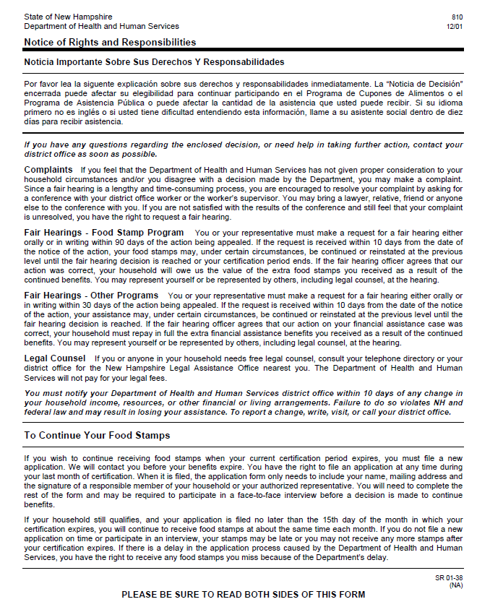

Service Authorization 810 Letter: Letter Layout Page 2 of 2
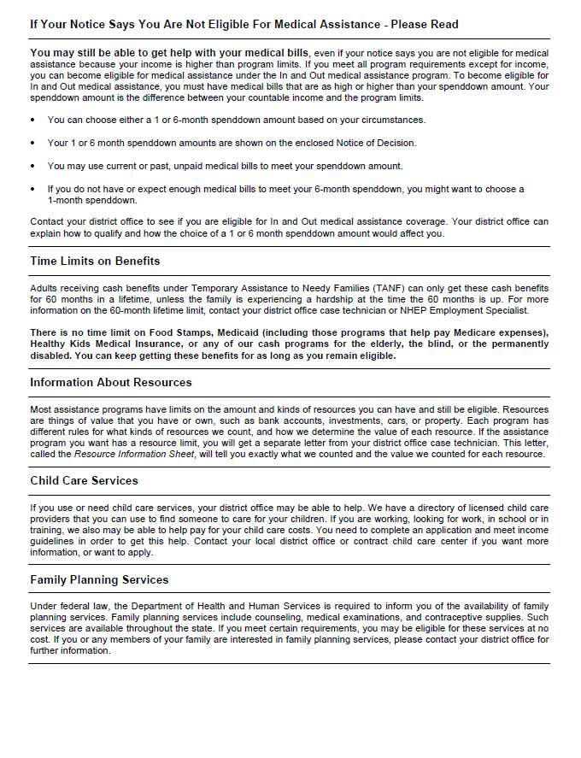

Service Authorization 810 Letter: Letter Specification
Service Authorization 810: Letter Specification
Letter Section Heading
Letter Section Logo (Required): |  |  | Letter Section Description (Optional):
None |  |  | None
Letter Salutation
Field Type | Business Label | Field Description |  | Source Table | Source Column and Keyword | Source Column Processing Rules
None

Letter Body
Field Type | Business Label |  | Field Description | Source Table | Source Column and Keyword |  | Source Column Processing Rules
None
Free Form Text (Optional)
None
Letter Closing
Field Type | Business Label
None
Letter Footer Contents
 |  | Letter Multipage (Required): i.e., 1 of 1 or 1 of 2: |  |  |  | Letter Template ID (Required):
None

